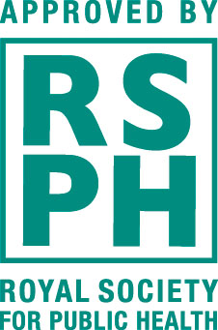
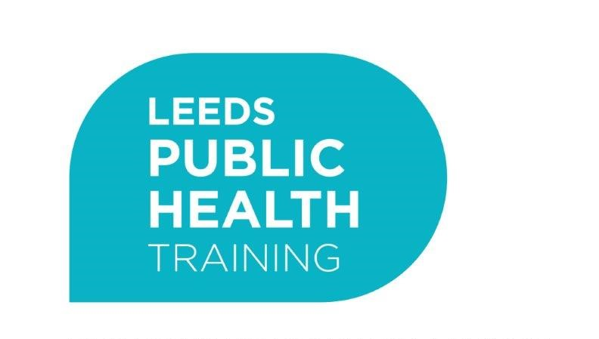

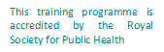

Leeds Health and Wellbeing Training Programme - Expression of Interest

Please note that the course launching in October 2024 will be delivered in person at the Public Health Resource Centre, Technorth. If you would prefer to access a future course digitally, we are planning to run the 2025/26 course as an interactive webinar. If this is more suitable for you, please email phforall@leeds.gov.uk and ask to be put on the 2025 webinar cohort waiting list.

Name
Job title
Name and address of organization
Email address
Telephone number
How did you find out about this course? e.g. PHRC website, PHRC newsletter, from a friend or colleague, other (please specify)
Is your service in receipt of Public Health funding? If yes, please provide name of contract, if known.
Does your manager support your application to the programme and attendance to all training dates, and are they aware of the £80 attendance fee?
Name of manager supporting your attendance on the programme
Invoicing postal address of organisation

Please let us know if the attendance fee would present a significant barrier to you attending. We may be able to provide support with this.
We are striving for the training to be as accessible and inclusive as possible. Please let us know if there are any accessibility needs we should be aware of.

Application statement (Please provide details about why you wish to attend the programme and what you hope to gain from it)

Data Protection
The Leeds Public Health team will use your details for the purposes of administrating and evaluating the session/s you have requested to attend e.g. we may contact you with information about the session/s; to send you resources relating to the session; and to invite you to participate in session evaluation.

Your personal information will be stored electronically, for no longer than 12 months, in accordance with the Data Protection Act 2018. It will not be shared with third parties without your consent unless the law requires us to do so.

Please only provide your details if you consent to them being stored and processed in this way.

If you require any further information, please contact us on phforall@leeds.gov.uk

Declaration
I consent to my information being stored electronically for the purposes outlined above, in accordance with the Data Protection Act 2018. I understand I can withdraw my consent at any time.

I provide my consent I do not provide my consent

I consent to receive information about future training opportunities sent to me by the Leeds City Council Public Health Workforce Development team and the Public Health Resource Centre by (please tick):

Email

Name

Signature
Date

Please send your completed form to phforall@leeds.gov.uk by Friday 14th June 2024

Please be aware that submitting an Expression of Interest does not guarantee you a place. Once the application deadline has passed you will be contacted as soon as possible with the outcome.

