Summer School for Newly Arrived KS2 Pupils 2024
Date & Time: 24th – 26th July & 29th – 30th July, 10:00 – 12:00
Venue: CATCH Leeds, ARK, Hovingham Avenue, Leeds LS8 3QY
Our summer school programme will run again this year, every morning from 24th – 26th July & 29th – 30th July 10:00 - 12:00. All pupils aged from 8 to 11 years old, who are new to English and/or new to school can attend. We aim to help the new arrivals:
Get ready to learn after the summer break
Develop oracy and fluency skills and build confidence
Discuss social and other aspects of school life 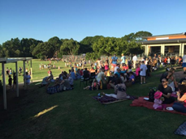

Please book for your pupils who would benefit from the programme. Contact email address for a booking form: wesley.wu@leeds.gov.uk or download the booking form from Leeds for Learning Website https://www.leedsforlearning.co.uk/Article/143783 Thank you.

