Background
Leeds Asylum Seekers Support Network (LASSN) works with some of the most at-risk people in the country: asylum seekers and refugees escaping persecution who can end up isolated destitute, with little hope and few choices.
LASSN was set up in 1999 following the Government’s decision to disperse asylum seekers around the UK. LASSN had the support of voluntary, community and church groups and was established to respond to some of the pressing unmet social needs of refugees and asylum seekers living in Leeds.
Our vision
Asylum seekers and refugees will be safe, respected, supported and empowered to rebuild their lives free of persecution.

Aims
LASSN has two aims. The first is to meet some of the social needs of refugees and asylum seekers by reducing isolation, providing advocacy support and encouraging self-help. The second is to raise awareness of issues facing refugees and asylum seekers based on our experiences.

Objectives
LASSN wants asylum seekers to be
- Supported and relieved from hardship and distress by local people
- Empowered to rebuild their lives, to fulfil their potential and to take control of their lives
- Integrated, settled and safe. LASSN wants Leeds to be a place of welcome and understanding and for the general public, organisations, politicians, and policymakers to understand the needs of Asylum Seekers.

How we work
LASSN works in ways which
- are Respectful of the contribution asylum seekers and refugees make to both LASSN and the UK
- are Informed and based on what asylum seekers and refugees say they want and value
- are Empowering both refugees and asylum seekers, and local people to help and support them
- are based on partnership - we seek good relationships with other organisations so that asylum seekers and refugees can access the kind of help and support they want and need
- sees Volunteers as vital to practical work with asylum seekers and refugees and recognises how much they benefit from their interaction with refugees and asylum seekers

Organisation Structure
LASSN is a registered company and charity with a voluntary management committee.
- The Chair line manages the Director.
- The Director provides line management to all staff;
- The Office Manager and the Admin and IT Coordinator provide financial and administrative support;
- The Volunteer Managers recruit and support volunteers;
- Volunteers undertake mentoring, befriending, home tutoring, hosting people in their homes, or supporting people living in one of LASSN’s houses. We sometimes get help from volunteer interpreters or with archiving.
- We also have a membership of around 100 people committed to the aims of LASSN.
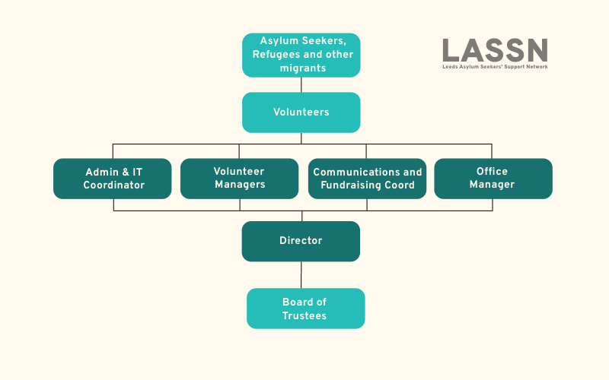

Beneficiaries
Yorkshire and Humberside are major asylum dispersal regions. Before asylum dispersal in Leeds, about 2,000 refugees were living in the city who arrived in the 1970s.
Since then, Leeds has seen more than 16,000 Asylum Seekers arrive in the city from 110 countries, with around 12,000 settling here once they receive their refugee status.
In April 2023, about 1,200 asylum seekers in Leeds received support from the Home Office. In August 2020, the total was 850.
There are no official figures on destitution locally or nationally – but Leeds agencies working with destitute asylum seekers report seeing about 1500 asylum seekers who are not receiving support from the State and who are staying with friends and family or who have nowhere at all.
Many asylum seekers and refugees experience acute isolation, language difficulties and immense uncertainty over their asylum claim. This can result in deterioration in both mental and physical health and well-being.
Most asylum seekers are highly skilled and motivated but are prevented from working while their claim is being assessed. Lack of purposeful activity can lead to a lack of self-confidence and a loss of self-respect and self-worth. For example, a young mother who was a respected primary school teacher in Zimbabwe described how, in the UK, rather than receiving respect, she has been made to feel like an unwelcome burden. This can lead to increased depression and anxiety.

Current Activities
- English at Home, where volunteer tutors are matched with asylum seekers and refugees who cannot attend mainstream English classes because of poor health, disability, or caring responsibilities.
- Hosting & Housing - where hosts offer hospitality in their homes (evening meal, bed and breakfast) for a few months at a time, or one of 2 properties where 4 destitute asylum-seeking men live for 12 months at a time, with mental health and social support.
- Information and awareness raising: we write about and talk on asylum issues through conferences and events, newsletters, talks and presentations, contributing to asylum training in the region, partnership working, and through our volunteer training programme where around 60 volunteers a year receive training on asylum issues. We run several websites with different purposes
  - lassn.org.uk tells the story of LASSN and reaches about 15,000 different people a year.
  - helpinleeds.com is an online directory of groups and services offering free help to asylum seekers and refugees in Leeds.
  - migrationpartnership.org.uk is a blog covering local asylum, refuge and broader migration issues.
  - We developed newtoleeds.org.uk as a guide for new migrants to Leeds.
- Welcome and connect - where volunteers are matched with asylum seekers and refugees to help them build their confidence, improve their English, and make contacts and friends in their local community, finding out about the help and services available.

