International Day of Disabled People
Marketplace

Event

FREE

Thursday 30 November 2023 | 11am - 3pm
Leeds City Museum

Celebrate the contribution of disabled people to Leeds!
Over 25 organisations with stalls
Lord Mayor of Leeds, Cllr K. Ritchie, plus special guest speakers
Interactive activities: Inclusive dance, ping pong, table cricket, circus skills - bring your support worker, personal assistant or carer
Quiet, sensory room BSL interpreter

Special guest speakers:
Craig Grimes
Jodie Boyd- Ward

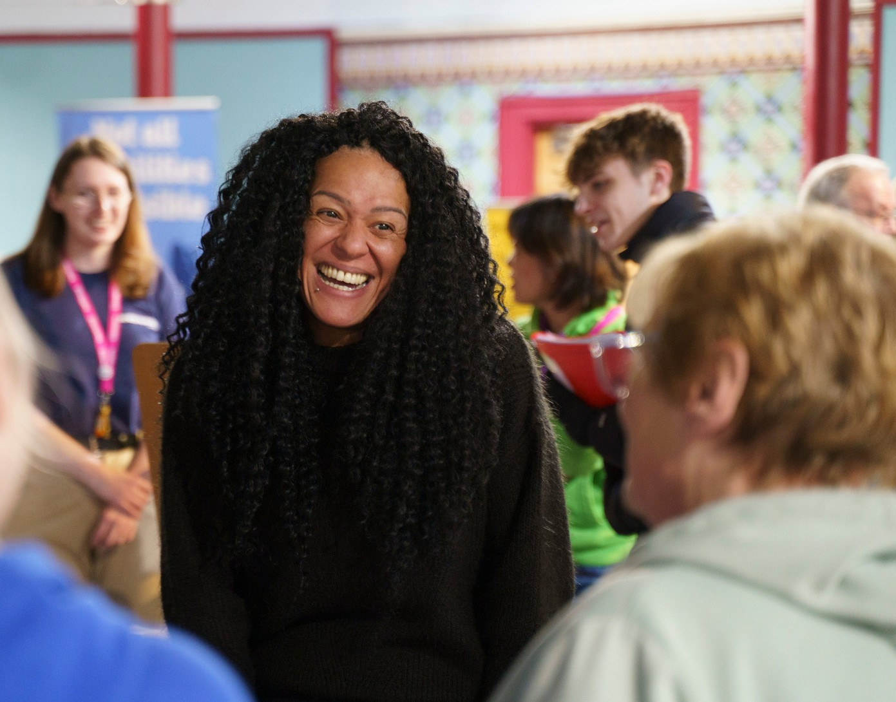
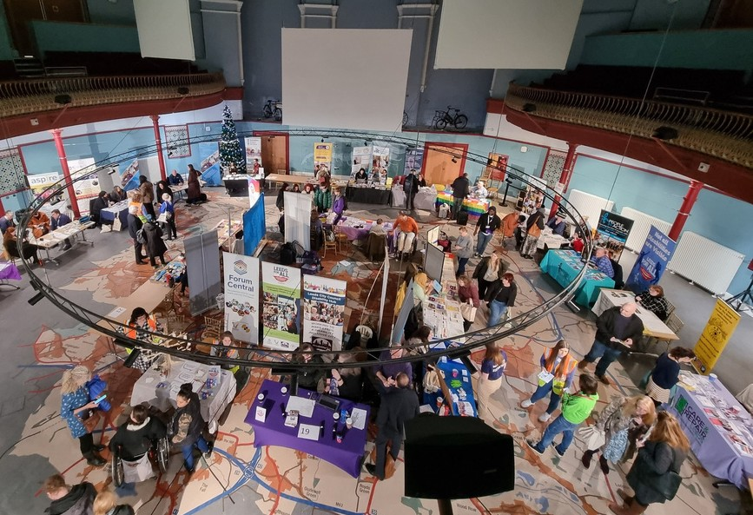
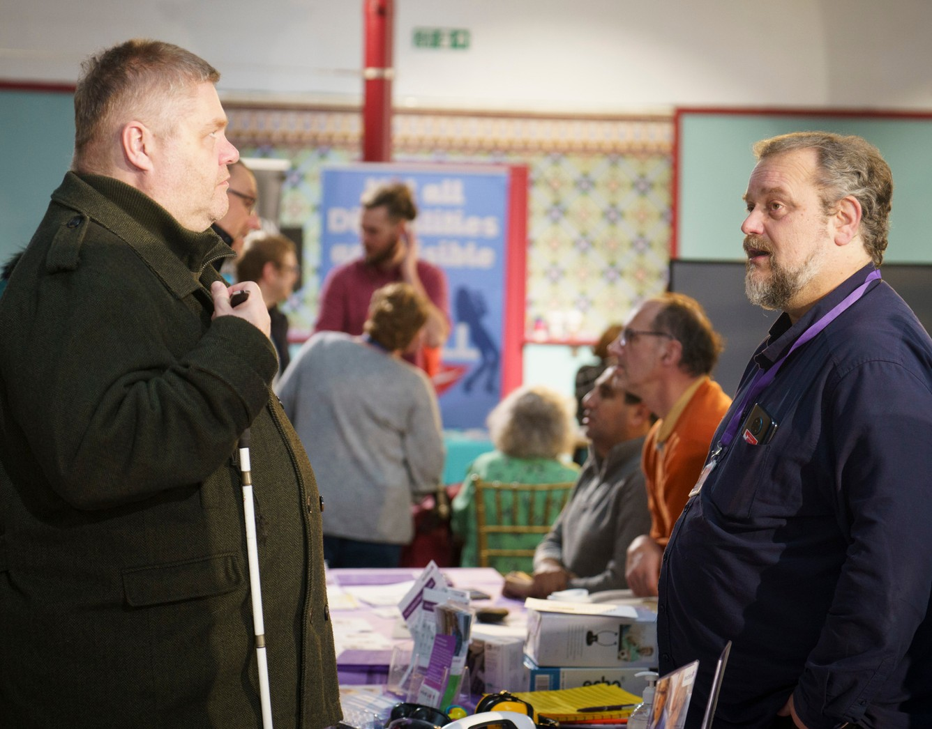
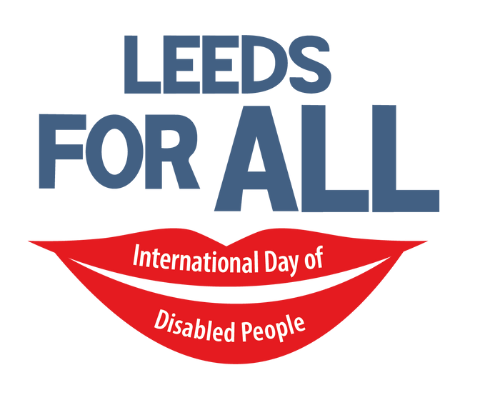
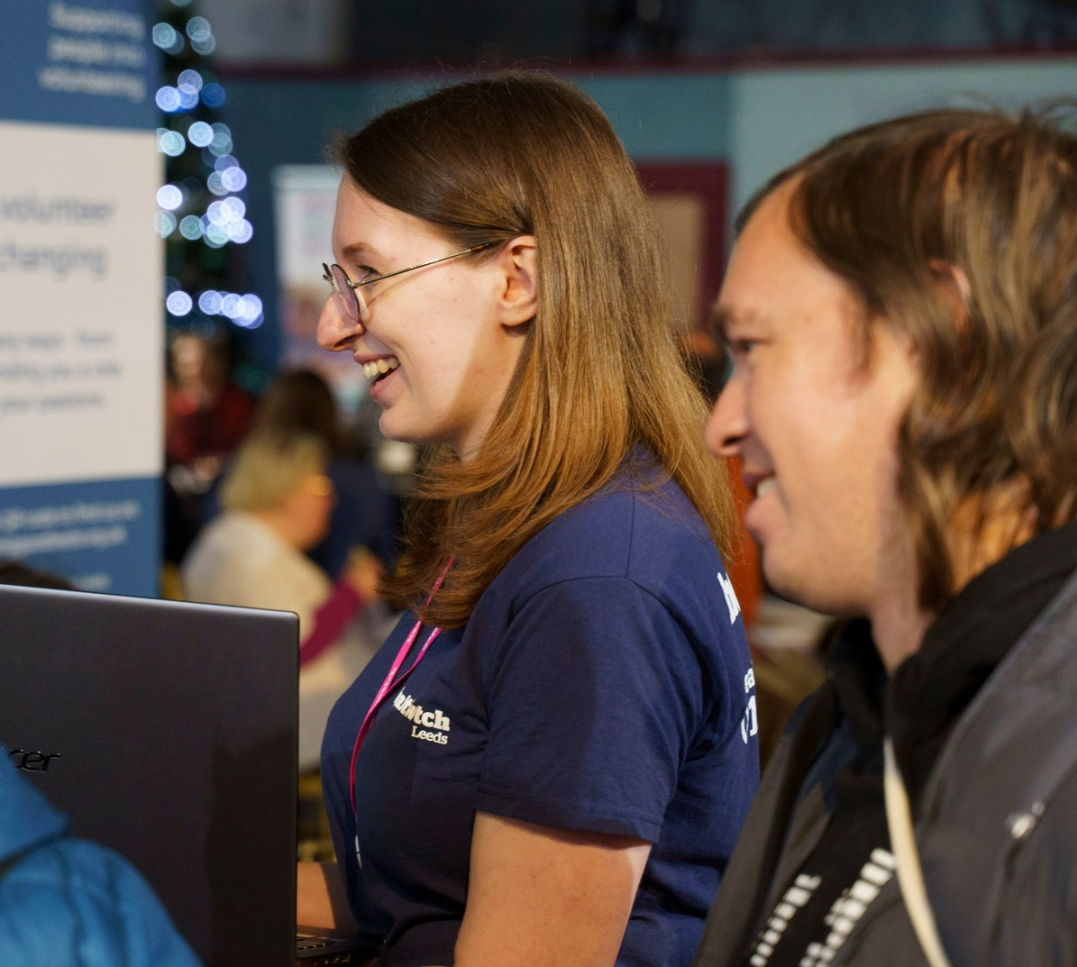
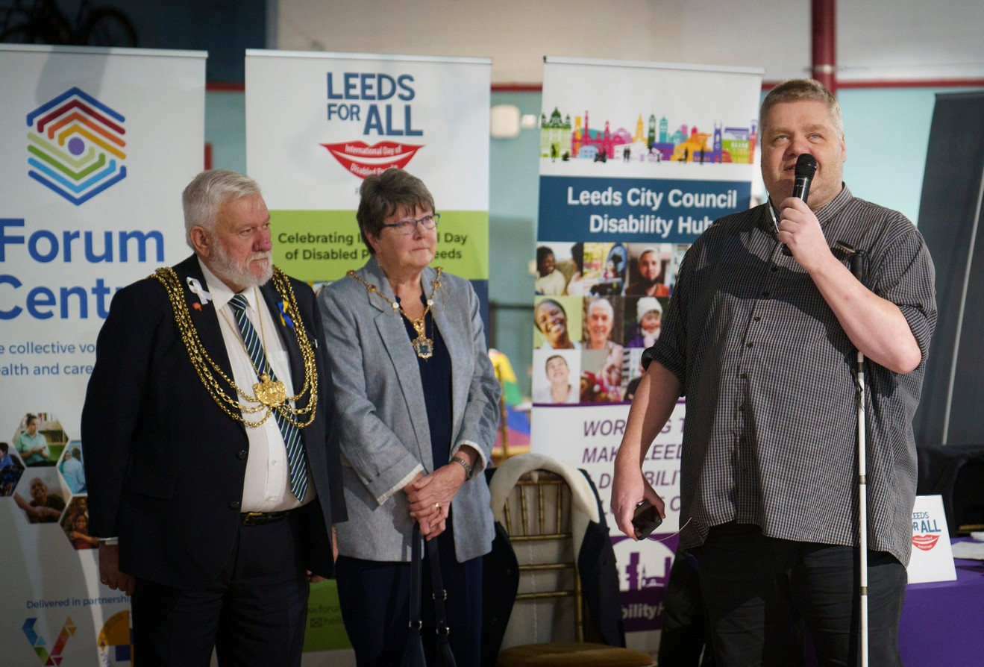
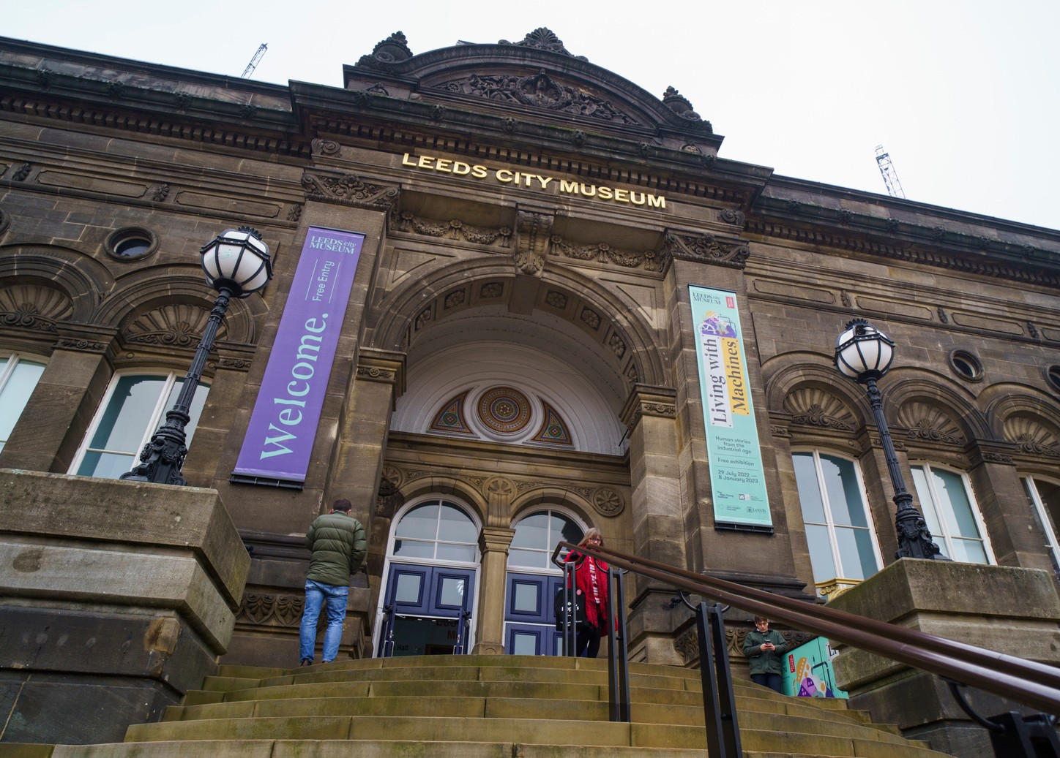
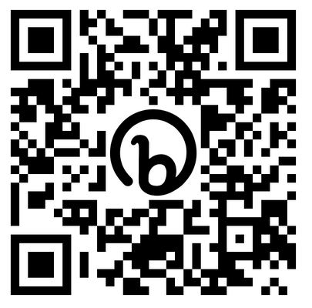
Find out more
Visit the Forum Central website: https://bit.ly/LeedsIDODP2023

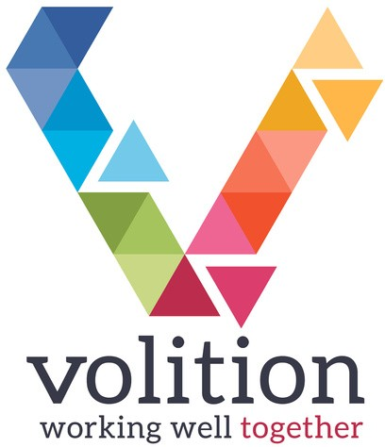
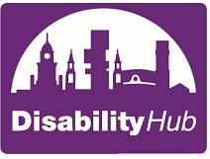
#LeedsForAll #IDODP2023

