Getting started
Logging in: http://migrationpartnership.org.uk/sansfrontier -
Please bookmark this URL in your browser
Please also reset your password to something secure, asap. A secure password is usually three words long with a mixture of upper and lower case letters, number and symbol – Eg BorisPaints100Buses!
You will be reviewing Posts (3rd option down on left hand side)
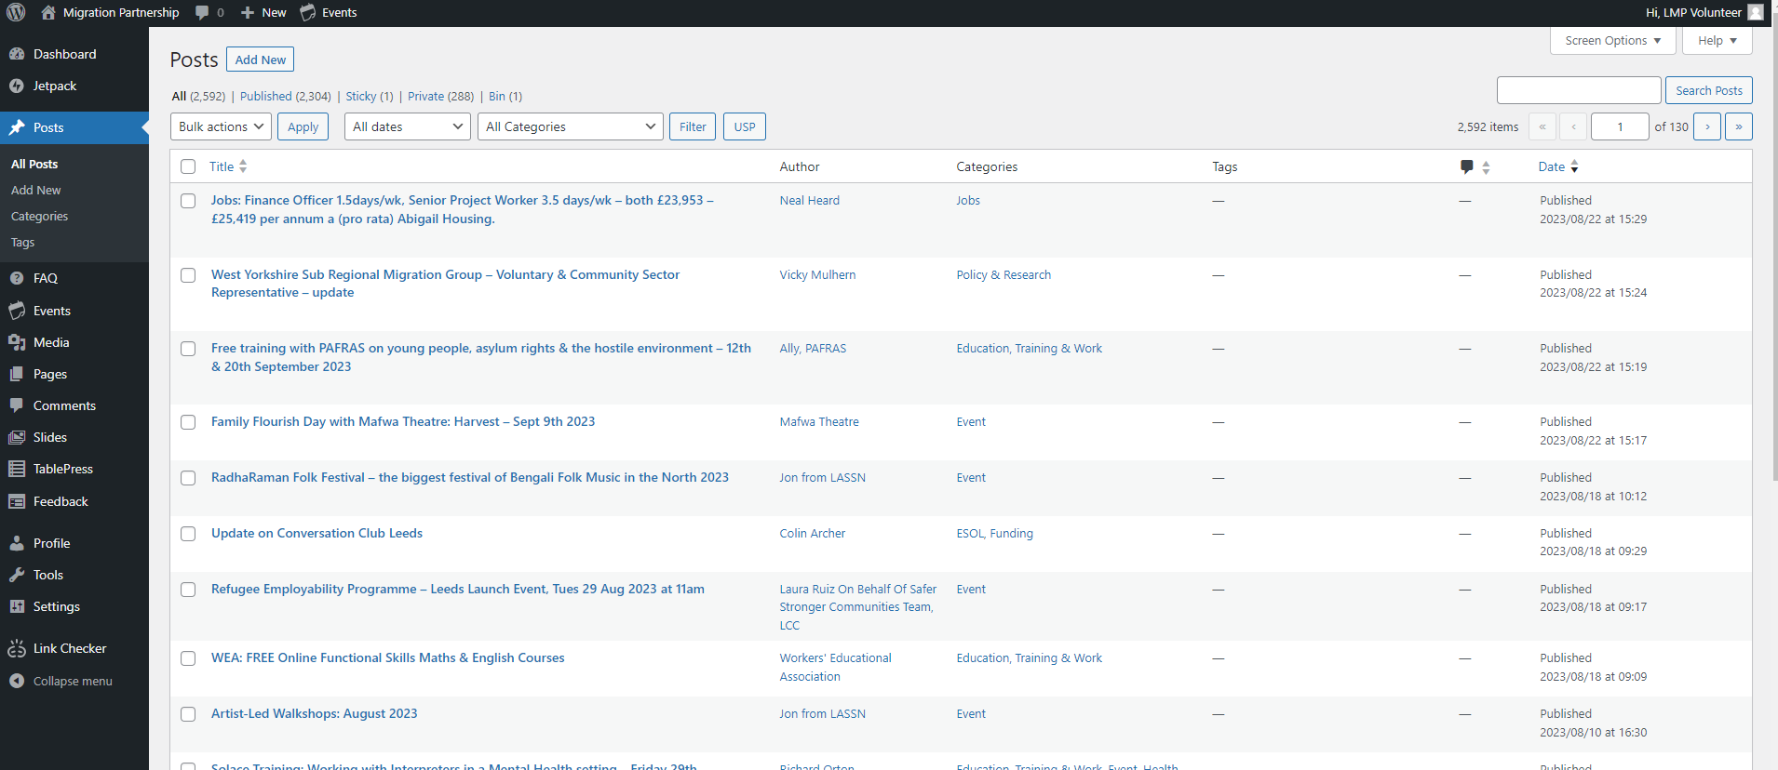

Your role is to check that all the elements are in place
- a good title,
- coherent body text,
- attachments or embedded documents
- the post is properly categorised
- You’ve previewed the post to see what it looks like

- A good title
Make sure that anyone skimming the weekly digest can understand what the article is about
- Sometimes this means rewriting the title.
- It’s usually helpful to put the date of an event into the title – including the year (eg 2023)
- With jobs we follow the following formula: Name of job, hours a week, pay pro rata, location organisation

- Coherent body text
- Editing: It’s fine to edit things if crucial info is missing, or it doesn’t make sense.
- Events: If it’s an event people will need to know what, when, and where it is happening. Sometimes this missing info can be embedded in an attachment
- No Links - If there are no links, are there any you could find easily? eg if a film is being advertised, is the trailer on youtube?
- Un-formatting text: If you are copying info from another place (eg a document or an email) please remove the formatting - you can do this by pasting the original text into something like Notepad (Windows) or TextEdit (Mac) - before pasting the unformatted text into the Blog post
- Formatting text – generally we DON’T DO ALL CAPITALS or things in different fonts/ sizes. The default is 12 point for Paragraph/body text.
- Links – Please check these to make sure they are working. If they don’t work, remove them (and maybe email the organiser?)

- Attachments or embedded documents
- Check to see if there are attachments or links in the custom fields section, and think about embedding these
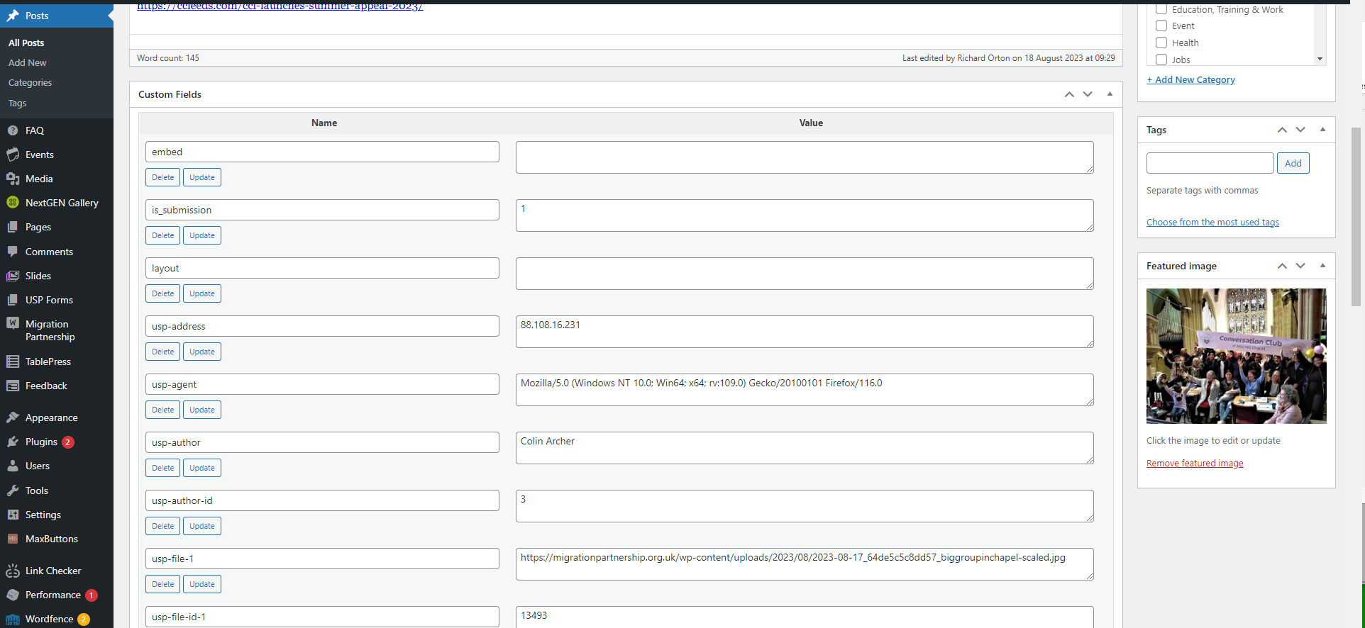
- To embed a word document or PDF
  - Find and copy the URL of the attachment
  - Place the cursor in the body text, where you wish to embed the attachment
  - Press the Add Document Button
  - Select Add from URL
  - Paste the URL into the box
  - Press the blue Add Url Button
  - Select Google Docs viewer NOT Microsoft
  - Press the blue insert button

- Categorizing posts
This makes posts easier to search/find.
Please make sure all posts are categorised before posting, using the categories on the bottom right hand side
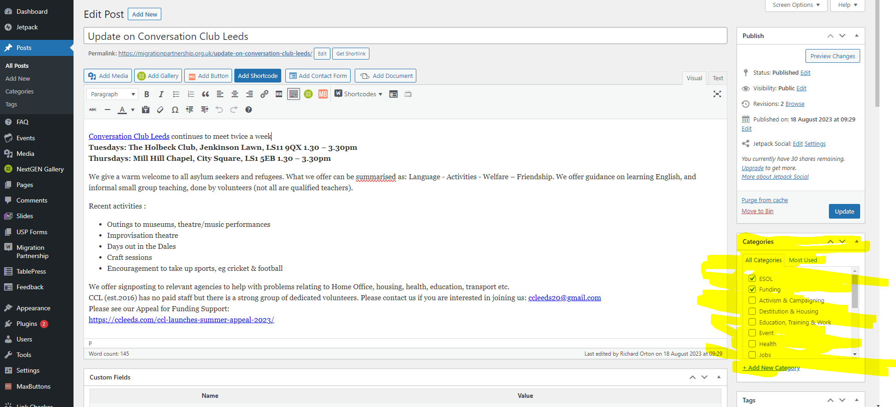

- Previewing the post
To preview the post, press the button on the top right hand side.
This will allow you to check/amend for any formatting errors
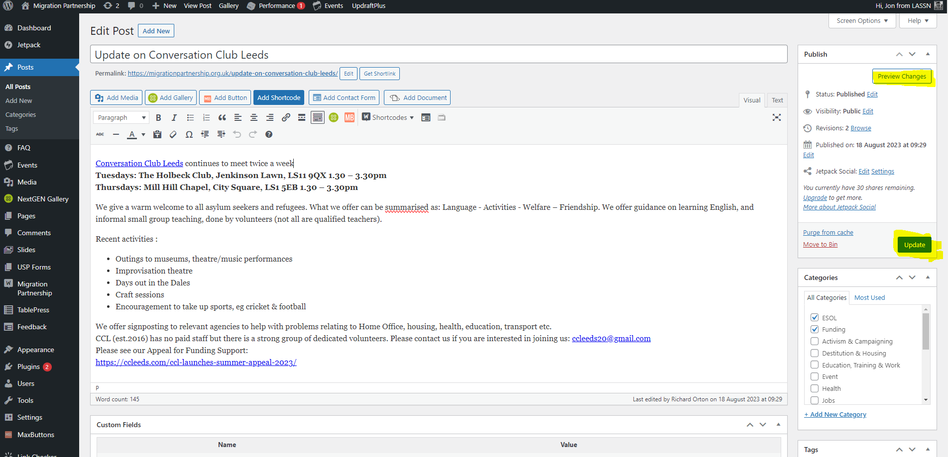

Posting the post
Once you have checked everything above you are ready to post.
To make your edits go “live” press update or post at the top right hand side of the screen.

Editing Pages
- Pages are static content that does not change very much.
- Links to Pages are in the the menu bar at the top of the page.
- Editing pages is just like editing posts

