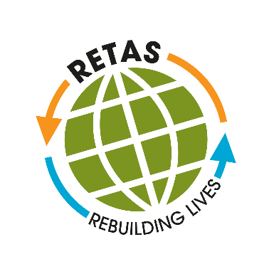

RETAS (Refugee Education Training Advice Service) is a charity set up to support refugees and asylum seekers living in Leeds and across West Yorkshire to reach their potential. Helping to integrate refugees and asylum seekers we provide assistance to with access to education, employment, training and requalification; we strive to build confidence and hope in our service users, empowering them to build a safe and secure life here in the UK.
RETAS is based in the heart of the community in Harehills where service users are free to drop in and feel at home. From this centre we offer the following services:
- An initial ‘Welcome to Leeds’ orientation service
- Our 28 Day Transition Project to enable asylum seekers who have very recently been granted refugee status to transition successfully from living as asylum seekers in HO accommodation, to living independently in alternative accommodation and integrating successfully into local communities
- New Roots Integration Project
- ESOL classes
- Digital & Financial Inclusion course
- IELTS (International English Language Testing System)
- 1 to 1 information, advice, and guidance
- Employability workshops including managing basic skills to university applications
- Volunteering and work placements
- Requalification routes and support for medical professionals
- Advocacy Support
- Signposting & Referral

RETAS also strives to raise awareness and understanding of refugees amongst the wider community, and in particular in the business and education sectors, where our clients are hoping to engage.
The vision of RETAS is ‘To improve the lives of refugees, asylum seekers and other vulnerable migrants predominantly in West Yorkshire’. Our business plan sets out a number of strategic objectives which outline how this vision will be met.
The organisation’s values set how the team are expected to work together, and how service users will be treated. Our values focus on six key elements:
- Welcoming
- Showing respect for difference
- Striving for excellence in our work
- Putting service users at the heart of everything we do
- Involving service users in our decision making

Job Purpose:
RETAS has grown substantially over the last few years. As a result, we have been able to offer the exciting post of Operations Manager (OM).
The successful candidate will sit on the Senior Management Team, second in line to the CEO, holding responsibility for the effective delivery, and evaluation of RETAS programmes.
As RETAS’ workforce grows in size it grows in diversity, with staff and volunteers (including asylum seekers and refugees) drawn from many different ethnic and cultural backgrounds. The OM will therefore require exceptional sensitivity and outstanding management skills in order to inspire and lead this team, in which individual differences are valued and utilised in pursuit of a common goal—RETAS’ mission.
The OM will also require extensive knowledge of the lives of asylum seekers, refugees, and other vulnerable migrants in West Yorkshire in order to develop and deliver programmes which are relevant to the needs, aspirations, and capacities of our service users.
The successful candidate will play a key role in consolidating existing work and shaping the organisation for future opportunities and challenges.

