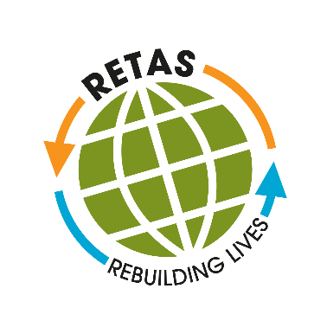
RETAS Leeds

Job Description

RETAS Operations Manager

Salary and contract details

- £32,020 full time post (35 hrs per week)

- Job location: RETAS Leeds, 233-237 Roundhay Road, Leeds, LS8 4HS

- Accountable to: RETAS CEO

- Duration: Permanent contract

“People with lived experience of migration with relevant skills and experience are strongly encouraged to apply”.

Main Responsibilities
- Manage, deploy, and develop the team of Advisers and Digital Skills Tutor
- Monitor performance against targets and deliverables for all contracts and funding agreements.
- Manage the 28 Day Transition project: line managing the delivery staff, co-ordinating the project and writing reports.
- Support employee activities and provide guidance where needed including coaching.
- Encourage a cohesive and inclusive work environment and culture for all employees.
- Lead in all operational Health & Safety matters, risk management and liaise with the landlord to ensure compliance with legislative requirements.
- Deputise for the CEO as appropriate.
- Provide occasional support and advice to service users.
- Engage in casework support with Advisers as part of CPD (Continuous Professional Development)
- Carry out Internal Audits to quality assure systems and processes.
- Liaise with the landlord to ensure building and equipment is fit for purpose and meets compliance standards. This includes IT, phone systems, office organisation, storage and building maintenance and safety.
- Produce monthly and quarterly contract and other management reports.
- Be responsible of providing information to support bids for funding from Trusts and others (Data collection)
- Coordinate internal staff meetings and other full-service events.
- Oversee the management and development of RETAS policies and procedures.

