West Yorkshire Police – Intelligence Submission Partnership Portal
Background:
- Designed to offer a simple internet based portal, to give key strategic partners the opportunity to submit information to a central police triage team.
- It is not designed to replace any current referral mechanisms in place; they must continue as per agreed service level agreements.
- The portal is there to submit the information that is routinely gathered by partners, we are not asking for any additional work on your behalf.
- It is for information about criminality that you feel would be of interest to West Yorkshire Police.
Contact details:
Julie Benson, Intelligence Evaluator, Intelligence Management Unit.
Phone - 01274 376454
Email – XC.PIPaccess@westyorkshire.police.uk
To request access:
https://www.westyorkshire.police.uk/form/intelligence-portal-request-form
Proposed process:
- Partner agency gathers information and assesses that it is pertinent to West Yorkshire Police.
- Access the portal and complete the intuitive screens.
- On submission it is automatically emailed to the Intelligence Management Unit (IMU) at West Yorkshire Police. This is a 24/7 unit that triages intelligence submissions for the force.
- The IMU triage the information submitted and if proportionate to record, they will transfer the details to our Intelligence computer system and task it to the appropriate resource in force.
Access to the partnership portal:
- Each partner will be given one log on to the portal, it will be shared amongst as many staff as that partnership deem appropriate.
- There will be a shared password within the organisation.
- Access will need:
    - Internet access.
    - A shared email mailbox account.
How it works:
Access to a unique URL will be given to each partner organisation that signs up to using the portal.
That URL provides access to the portal; this access can be shared within an organisation to whoever you feel it most appropriate.
There will be one shared log on, one shared password per organisation – this is to manage a simple administration process for both partner and the police.

Access:
Go to https://www.westyorkshire.police.uk/form/intel-submissions-form-check

Log in screen:
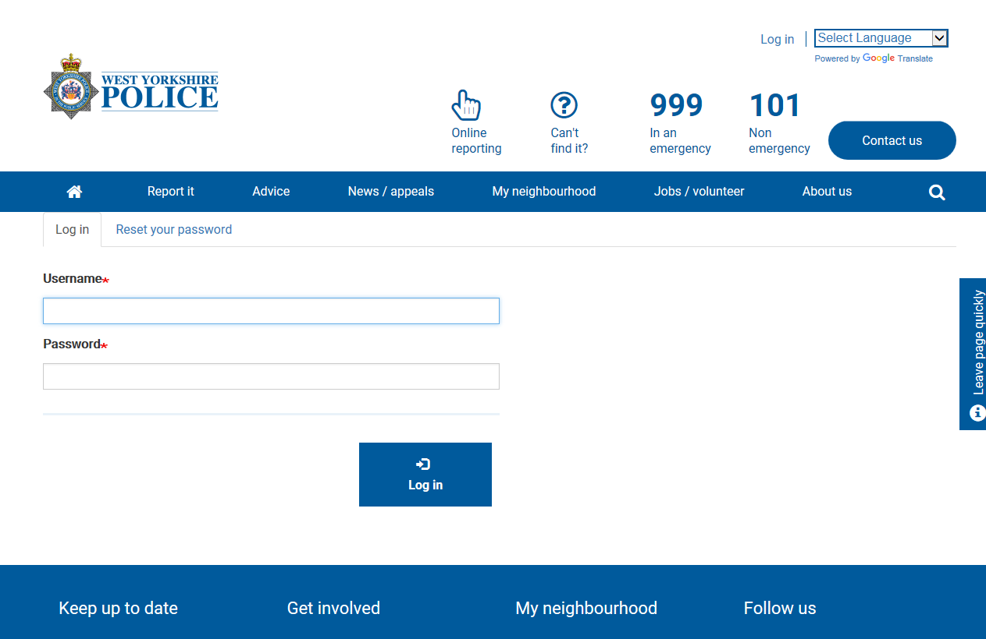
Enter group email account followed by shared password to gain access to the portal.

Once logged in you will be taken to the intelligence submission form
Screen 1 – opportunity to triage out spontaneous crimes/incidents:
The following 3 questions are to prompt the user to think about the information they have.
The questions are to allow us to filter out:
Incidents or crime that are in progress.
Reports of crime.
Relevance to West Yorkshire Police.

The portal is only for the recording of information about criminality within West Yorkshire. No other force is part of this process.
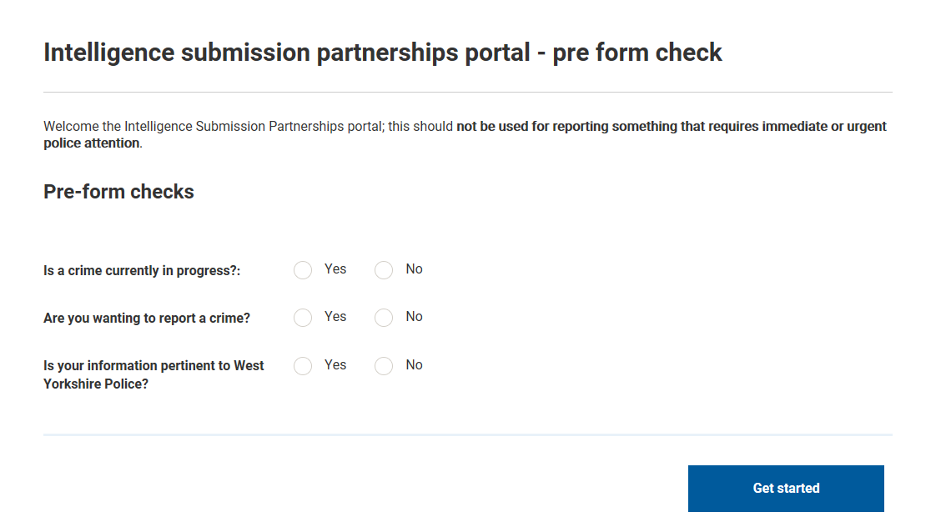

Your contact details:
It is essential we know who has submitted the information and from which organisation. The evaluation process carried out by the Intelligence Management Unit may mean they wish to contact the submitter to clarify the information supplied.
All fields that show a red asterisk * are mandatory.
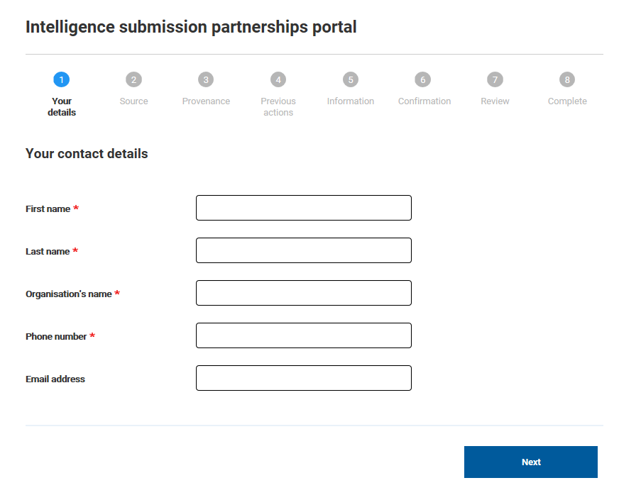
Source:
The Source is defined as the person supplying the information. This may be observational information (something they see) that comes from an organisations worker, in that case you would supply their details as the Source.
If the Source is a client of your service and they have offered the information, then you would record them in the Source details fields.
Reassurance can be given to any Source that their details are kept Confidential; they will never be divulged to the Subject/Suspect of the intelligence. They are recorded on a Confidential Police database with extremely limited staff access.
If a Source does not wish to provide their details, simply complete the mandatory fields with REFUSED.
Our ideal minimum standard is:
- Given name
- Family name
- DOB
- Address
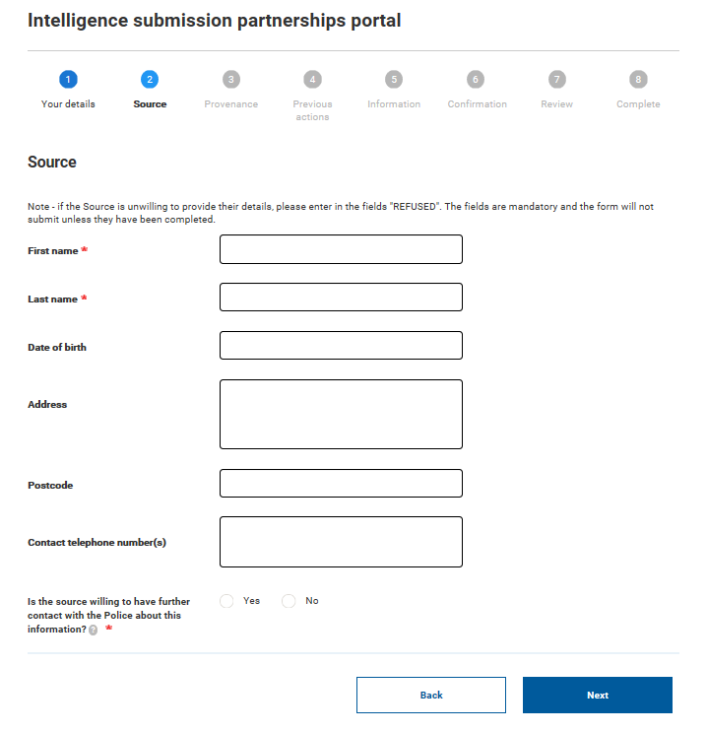
Please ask the Source if they are willing to be contacted by the Police. This contact can be via your organisation if they wish.
If they are happy to be contacted, we need to know their wishes about contact e.g,
- Use only their mobile number.
- Ask for them by first name only.
- Don’t divulge it is the Police calling until ascertained they are speaking to the Source.

Provenance:
The provenance is the history of the information on offer. Knowing the provenance allows police decision makers to assess:
- Credibility of the information,
- How many people know the information; therefore what is the risk (if any) to the Source.
- What tactics do we employ to develop and action the information so we protect the identity of the Source.
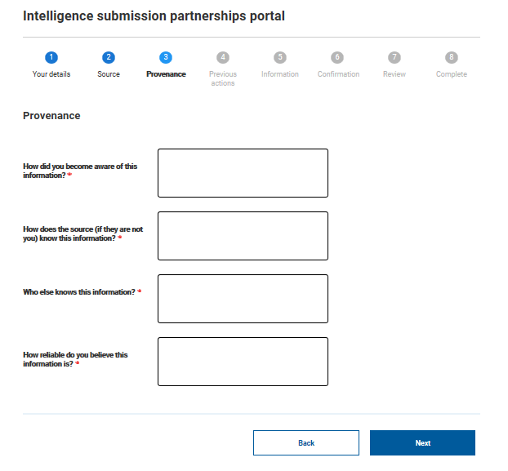

Previous Action:
If you have done something about the information, such as referred it previously to West Yorkshire Police, then it is useful for us to know. Again this allows us to consider what tactics we employ to develop/action the information.
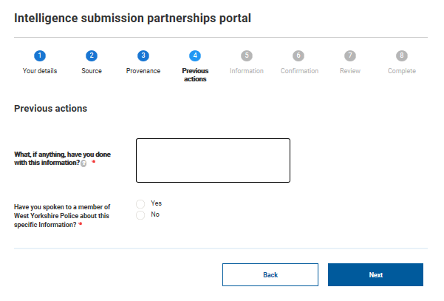
This field allows us to discuss with the Officer/Staff member any action they have taken with the information, so we do not duplicate effort.
Information:
This screen allows you to record the information gathered. Please be as clear and concise as possible. Please do not feel you have to use ultra-professional or complex language; please feel free to use plain English, be to the point and if the subject matter is of a sensitive nature please do not shy away from including all details no matter how graphic or potentially harrowing. The Intelligence Management Unit are used to evaluating information across a wide range of crime types.

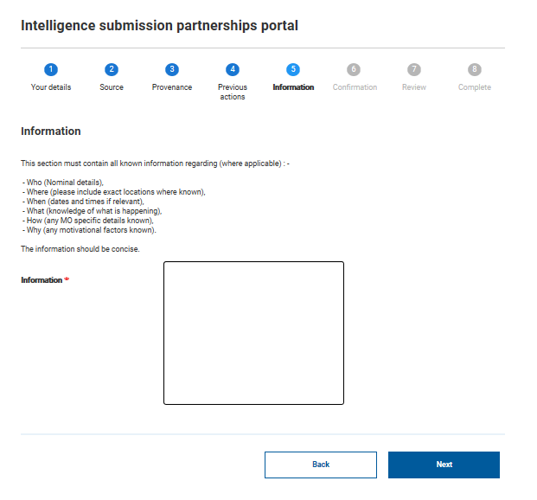

Final check
This screen is simply confirming the portal is not being used to report any incident or crime that requires immediate police attention.
The portal is managed by a unit that operates 24 hours a day, 7 days a week; however it is one aspect of a complex and demanding triage process which manages in excess of 500 information/intelligence submission per day. This level of demand comes with inherent delays in managing anything of a spontaneous or urgent nature.
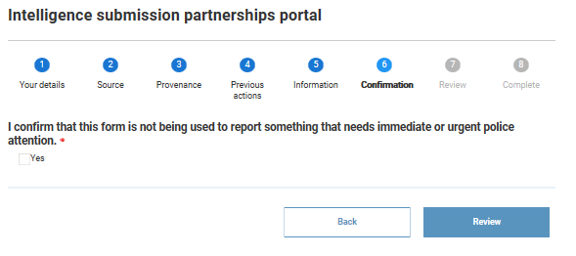

Final page – submission
This page allows the submitter to review the information they have entered. The submitter can go back and make any changes if required.
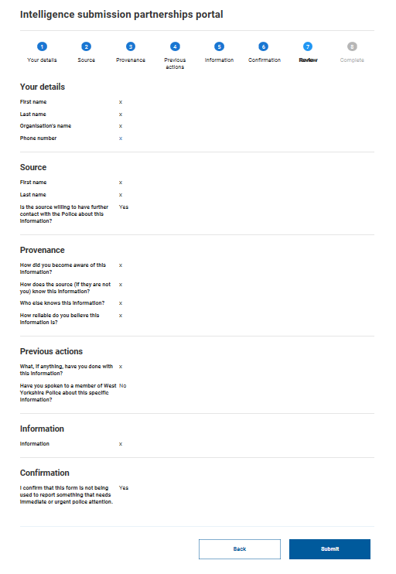
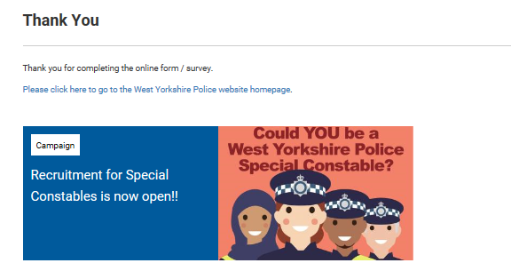
Once you see this screen you have successfully submitted your information.

