Mental Health Support in Leeds

- Crisis support
- Mental Health Support
- Abuse Survivors
- Young People
- Counselling/Emotional Support
- General Wellbeing

Crisis support
Leeds Crisis Team
Freephone: 0800 183 1485
If you are feeling very distressed, hopeless or having suicidal thoughts it’s important to know that you are not alone. Talking to someone can help you see beyond how you’re feeling right now. You could try talking to a family member or friend, or, if this doesn’t feel right, there are people who want to talk to you and can help.
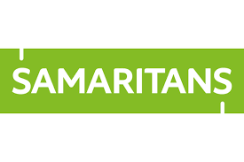

Samaritans
Freephone: 116 123
Email: jo@samaritans.org
Web: www.samaritans.org

Whatever you're going through, a Samaritan will face it with you. We're here 24 hours a day, 365 days a year.

SHOUT
Web: https://www.giveusashout.org/
Text: Text SHOUT to 85258

24/7 crisis text service, free on all major mobile networks, for anyone in crisis anytime, anywhere. It’s a place to go if you’re struggling to cope and you need immediate help.

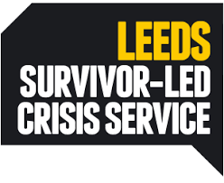
Connect Helpline
Phone: 0808 8001212

Telephone support line opens from 6pm to 10:30pm every night for those who are lonely, distressed or anxious or carers of those with emotional issues.

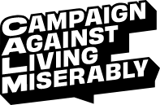
CALM – Campaign Against Living Miserably
Web: https://www.thecalmzone.net/
Phone: 0800 58 58 58

Offer support to men in the UK, of any age, who are down or in crisis via a telephone helpline, webchat and website.

Papyrus – Prevention of Young Suicide
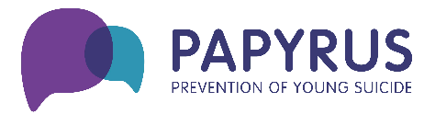
Web: https://papyrus-uk.org/
Phone: 0800 068 41 41

PAPYRUS is the national charity dedicated to the prevention of young suicide. Service offers advice to young people under 35 who are struggling with suicidal thoughts.
Service offers:
- Helpline
- Downloadable support resources – safety plans, distraction techniques, coping strategies, hope book, conversation starters, coping with exams and change, etc
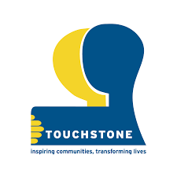
Well-bean Hope In a Crisis Café
Professional Referral Contact: 07760 173505
Self-Referral Contact: 07760 173476
Website:
https://touchstonesupport.org.uk/intensive-community-support/wellbean-cafe/well-bean-hope-in-a-crisis-cafe-leeds/
The Well-bean Hope In a Crisis Café supports anyone in a crisis – it provides a safe place for people in crisis to go and to prevent avoidable attendances at A&E.
The Leeds Hope and Well-bean Crisis Café is a partnership between Leeds Survivor Led Crisis Service and Touchstone (who are leading on the project). The café runs at three different venues across the week from 6pm to midnight:
Saturday, Sunday and Monday – the WBC is at Lincoln Green Community Centre, Cromwell Mount (LS9 7JB)
Tuesday and Wednesday – the WBC is at Touchstone House, 2-4 Middleton Crescent, Beeston (LS11 6JU)
Thursday and Friday – the WBC is at New Wortley Community Centre, 40 Tong Road (LS12 1LZ)
Asylum seekers/Refugees: No Confirmation.
Has access to interpreters: No Confirmation.

Dial House
Phone: 0113 260 9328
Text: 07922 249 452
Website: https://www.lslcs.org.uk/services/dial-house/
Email: simon.richardson@lslcs.org.uk
Dial House is a place of sanctuary open 6pm–2am every Monday, Wednesday, Friday, Saturday and Sunday evenings.
Visitors can access Dial House when they are in crisis, relax in a homely environment and have an hour of one-to-one support from the team of Crisis Support Workers. We transport visitors to and from the house by taxi to ensure their journeys are safe and comfortable.

We work regularly with people at the extreme end of mental health crisis, who present with behaviour other services find challenging; with issues such as dissociation, hearing voices, self-harm and plans to end their lives. We aim to provide a compassionate and containing experience for visitors.
Asylum seekers/Refugees: YES- Look into Dial House @ Touchstone, specifically for clients from ethnically diverse communities
Has access to interpreters: Statement on interpreters:
‘We are currently reviewing our capacity to find ways to make our services more accessible to non-English speakers. This can often be a challenge as working with people in crisis it is hard to anticipate when an interpreter might be needed and securing the right interpreter at the right time at short notice. We do use BSL interpreters and would seek to find interpreters on request if we knew of someone seeking support who needed one. We also have some limited capacity to offer support in language skills possessed within the team.’
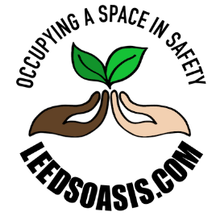
Leeds OASIS
Website: https://leedsoasis.com/
Leeds OASIS is a new option in the existing LYPFT crisis pathway, offering an alternative to hospital admission for those that do not necessarily need a bed on an acute ward and for whom a homely environment may be more beneficial. The service is a partnership between LSLCS, Touchstone and LYPFT, launched July 2021.
The Leeds OASIS service provides a homely environment, similar to existing third sector crisis services such as Dial House and the Well-Bean cafes, providing Person-Centred therapeutic support and employing Trauma Informed Practice.
Individuals will be able to access the service for up to seven days; this could be overnight or daytime only for those with commitments, such as children or pets. All rooms have ensuite bathrooms and a safe for medication.
The service is staffed by Crisis Specialist Workers who can support the individual during their crisis to prevent further escalation and explore ways to manage future episodes of crisis. Anyone accessing the service will have an allocated worker from one of the home based treatment teams of LYPFT (IHTT/CRISS), who will be in daily contact with the individual and the OASIS team; in order to provide additional support during their stay and facilitate joined-up care.
Access:
- Anyone with an existing crisis referral with CRISS or IHTT could be considered, with CRISS deciding if a referral to OASIS is appropriate
- Those already with secondary mental health services (CMHT, Aspire, PDCN and AOT) should contact CRISS to discuss
- Anyone not with secondary mental health services may be referred to SPA for an urgent assessment, of which the OASIS service may be an option

Asylum seekers/Refugees: YES
Has access to interpreters: No Confirmation.

Mental health
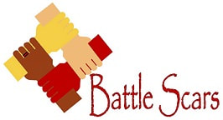
Battle Scars
Phone: 07410 380747
Web: http://www.battle-scars-self-harm.org.uk/
Email: info@battle-scars-self-harm.org.uk
Facebook: www.facebook.com/battlescarsselfharm/
Survivor led group in Leeds, to support anyone who self harms, their families and carers, or anyone who is trying to understand self harm. The aim of the groups is to provide a safe space to express ourselves, understand our self harm issues, get support, feel better about ourselves and learn. Also have a survivor lead Facebook support group and online resources for professionals.
See website for upcoming dates.

Asylum seekers/Refugees: YES
Has access to interpreters: NO

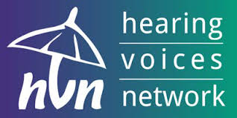
Leeds Hearing Voices Group
Saturdays, 4.00 - 7.00pm
Touchstone Support Centre, 53-55 Harehills Avenue, LS8 4EX
Phone: Patrick | Tel: 0113 260 9328
Email: Patrick.gatewood@lslcs.org.uk
Website: www.lslcs.org.uk
Leeds Survivor Led Crisis Service runs a Hearing Voices Group weekly on a Saturday afternoon.
This group runs from 4.00 – 7.00pm
The group is facilitated by one voice hearer and one non-voice hearer but both have experience in living with mental issues too.
If you would like any more information please feel free to call and talk to a member of staff on 0113 260 9328 or email Patrick.gatewood@lslcs.org.uk

Asylum seekers/Refugees: No Confirmation.
Has access to interpreters: No Confirmation.

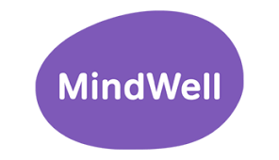
Mindwell
Website: https://www.mindwell-leeds.org.uk/
Provides a portal for anyone living or working in Leeds, including GPs and other professionals, to get quick and easy access to up-to-date mental health information, including:
• Clear, accurate information about support and services available in Leeds.
• Information about a range of common mental health problems such as anxiety and stress.
• How to look after your mental health and help yourself to feel better.
• Self-help information including downloadable resources, videos and animations.
• Help for what to do in a 'crisis' or mental health emergency.
• How to find support for practical issues such as problems with benefits and housing or money worries.
• Information to support people such as carers and new parents or parents-to-be.
All information can be translated and/or read out for those who struggle with reading or where English is not their first language.
Abuse Survivors
Bens Place
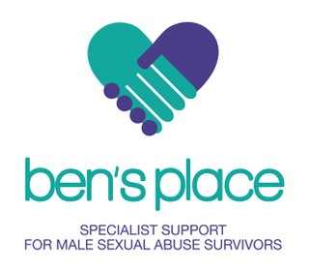
Web: https://survivorswestyorkshire.org.uk/bens-place/online-services/counselling-referral/
Email: ops@survivorwestyorkshire.org.uk
Ben’s Place is a free specialist support service for male sexual abuse victims in West Yorkshire.
Services include:
- Email support
- One to one and group specialist counselling
- Male online peer support group
Self or professional referrals accepted.

Asylum seekers/Refugees: YES
Has access to interpreters: NO

SARSVL – (Support after rape & sexual violence Leeds)
Free Helpline: 0808 802 3344
Text: 07860022880
Web: http://supportafterrapeleeds.org.uk/helpline/counselling/
Email: support@sarsvl.org.uk
Working with women and girls who have been affected by rape, childhood sexual abuse or sexual violence at any time in their lives. We provide a safe space for you to talk about how rape or sexual violence has affected you and we can help you to explore your options.
Helpline, Advocacy, Counselling.
Asylum seekers/Refugees: YES
Has access to interpreters: YES*
*Helpline is via English only, but clients can speak via text or email too.

Mondays @ Northpoint – Support for women
Email: mondays@northpoint.org.uk
Address: Northpoint Wellbeing, Leeds Bridge House, Hunslet Rd, Leeds, LS10 1JN
Website: https://northpoint.org.uk/mondays-thursdays-northpoint/
A free emotional wellbeing service for women who have been sexually abused in childhood. Contact us now if you want a confidential space to think with a trained professional about what you have been through and how to move forward in life.
What: a 90-minute initial appointment to think about longer term support.
Accepts self and professional referrals.
Asylum seekers/Refugees: YES
Has access to interpreters: NO

Thursdays @ Northpoint – Support for Men
Email: Thursdays@northpoint.org.uk
Address: Northpoint Wellbeing, Leeds Bridge House, Hunslet Rd, Leeds, LS10 1JN
A free emotional wellbeing service for men who have been sexually abused in childhood. Contact us now if you want a confidential space to think with a trained professional about what you have been through and how to move forward in life.
What: a 90-minute initial appointment to think about longer term support.
CURRENTLY CLOSED TO REFERRALS
Asylum seekers/Refugees: YES
Has access to interpreters: NO

Victim Support – WEST Yorkshire
Web: www.victimsupport.org.uk
Office hours helpline: 0300 303 1971
Out of hours support Freephone: 08 08 16 89 111
Offer support to anyone affected by crime whether it has been reported to the police or not. Support is free, confidential and tailored to your needs. Aimed at supporting people to feel safer and finding the strength to move beyond the crime.
Accept self referrals and referrals from other professionals. In order to make referrals, please contact on 0300 303 1971 or make contact through the Victim Support website.
Asylum seekers/Refugees: No Confirmation.
Has access to interpreters: No Confirmation.

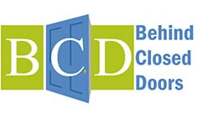
Behind Closed Doors
Phone: 0113 222 4202
Web: http://www.behind-closed-doors.org.uk/
Email: info@behind-closed-doors.org.uk
Behind Closed Doors helps people throughout Leeds whose lives have been, or are, affected by domestic violence and abuse to cope, recover and move on from their experiences.
Support is provided by phone and through 1-1 face to face sessions in the community in a safe location.
Our support services are delivered by two teams:
- Community Domestic Violence Team (part of Leeds Domestic Violence Service) - offering advice, advocacy, and practical support to those who are at high risk as a result of their abusive relationship.
- Prevention and Recovery Service (PARS) - offers a non-crisis response structured programme of emotional support to those affected by domestic violence and abuse who are at low risk of harm, helping them to make sense of their experience, recover and move on positively.

Self-referral or professional referral if person has given consent. See website.

Community DV Team
Asylum seekers/Refugees: YES
Has access to interpreters: YES
PARS service
Asylum seekers/Refugees: NO
Has access to interpreters: NO

Young People

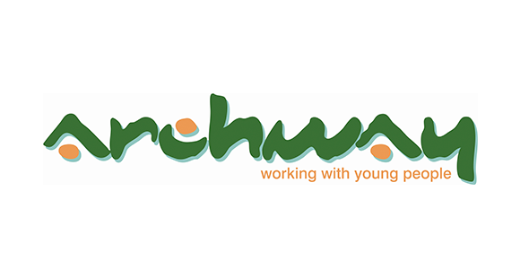
Young People at Archway
Phone: 0113 391 8000
Address: 95 Roundhay Road, Leeds, LS8 5AQ
Website: https://gipsil.org.uk/services/young-people-at-archway/
Offers free, confidential counselling for 16-25 year olds for up to 12 sessions.
Other services include housing support, benefits advice and employment support. They also have several groups running. These currently include dance, boxing, gym group, cookery and women’s multi-sports. These groups are usually totally free or low cost.
Asylum seekers/Refugees: No Confirmation.
Has access to interpreters: No Confirmation.

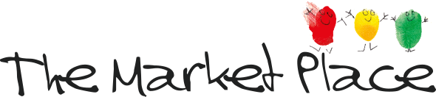
The Market Place
Phone: 0113 2461659
Web: http://www.themarketplaceleeds.org.uk/ / https://www.themarketplaceleeds.org.uk/services/counselling/
Email: admin@themarketplaceleeds.org.uk
Address: 8-18 New Market Street, Leeds, LS1 6DG
Counselling, support and advice for young people aged 11-25.
We offer:
- Long-term Counselling for 11-23 years olds (for up to a year)
- Bereavement Counselling for 11-19 year olds (6 sessions)
- Short-term Counselling for 11-23 year olds (12 sessions)
- Fast Access Counselling and Support for 11-25 year olds (4 sessions)
- We also offer faster access to longer-term counselling for young people who are Looked After or are Care Leavers.
Counselling sessions themselves last for about 50 minutes and are offered on a weekly basis, at the same time and on the same day each week.

Asylum seekers/Refugees: YES
Has access to interpreters: NO
Kooth
Web: https://www.kooth.com/
The online service for 10-18 year olds, that offers FREE, same-day, BACP accredited support, counselling, advice and activities.
This means you can signpost any 10-18 year old to Kooth as an additional, or sole, means of mental health support. There aren't any thresholds or criteria to meet, and no waiting lists! The young person can sign themselves up anonymously on the Kooth.com website as our service is self referral.

Asylum seekers/Refugees: YES
Has access to interpreters: Their statement:
‘Users currently have to be able to speak English Language to access the website or be able to translate from their native language to English, and then copy and paste that text in the chat/counselling feature on the site (you access counselling/ chat through text-based chat rooms with our practitioners/counsellors on the Kooth website. There's no telephone call/ video call feature as users sign up anonymously, and it's online support).’

Counselling/ Emotional Support

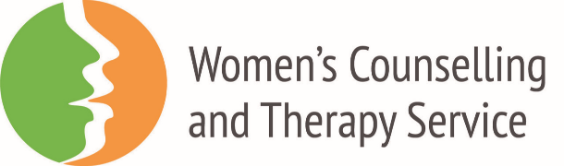
Women’s Counselling & Therapy Service
Phone: 0113 2455725
Web: http://www.womenstherapyleeds.org.uk
(waiting list opens and closes regularly so please check website before signposting clients)
Women’s Counselling and Therapy Service offers a free or low cost accessible counselling and psychotherapy for Leeds women and girls on low incomes. Waiting lists open and close so that there aren’t long waiting lists. Offers 1:1 counselling, but also group sessions.
Asylum seekers/Refugees: YES
Has access to interpreters: YES
Currently accepting referrals for women who are pregnant or have an infant under 1
Self-referral or professional referral. Check website to see if wait list open.
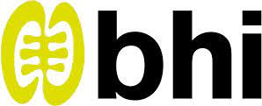

Black Health Initiative
Phone: 0113 3070300
Web: http://www.blackhealthinitiative.org/
Email: admin@bhileeds.org.uk
Provides a confidential counselling service to African, African Caribbean, Dual Heritage and other minority ethnic adults and young people aged 13+.

Asylum seekers/Refugees: No Confirmation.
Has access to interpreters: No Confirmation.

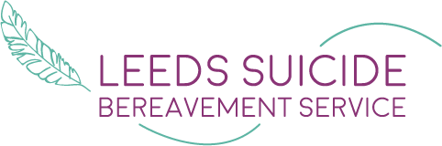
Leeds Suicide Bereavement Service
Phone: 0113 3055803
Web: http://leedssbs.org.uk/
Email: info@leedssbs.org.uk
Compassionate support for people bereaved by suicide.
The project is run by Leeds Mind and Leeds Survivor Led Crisis Service. The workers have their own personal experience of suicide bereavement.

You can access support as an individual, family or work place. We provide 1:1, peer groups, family support and counselling. Whether you were affected by a suicide that was a few days, weeks or decades ago. We will support you whoever you have lost – this may be a parent, child, partner, sibling, other relative, friend or work colleague.

Self-refer through website.

Asylum seekers/Refugees: YES
Has access to interpreters: YES

Solace
Web: http://www.solace-uk.org.uk/
Email: info@solace-uk.org.uk
Telephone: 01138246796 or 07899304905
Provide psychotherapy, complementary therapies and advocacy support to the survivors of persecution and exile living in the Yorkshire and Humber region, many of whom have been traumatised by torture, rape, the death or disappearance of loved ones and often combinations of all of these and other atrocities.
The waiting list for adult therapy in Leeds is temporarily closed. We will continue to review this and re-open as soon as we can.
We offer advice and consultation if you have a query with regards to the correct service for your referee. You can call the Solace office on 0113 8246796 to be directed to the right person to assist you.
For Farsi speaking males, you can make a referral to the Solace group sessions.
Solace continues to offer therapeutic services to refugee adults resettled through the UNHCR in Leeds.
We are open for, and welcome, referrals into our Children and Families Wellbeing Project, and Connecting Opportunities project.
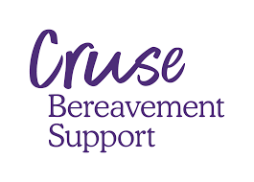
CRUSE Bereavement Care
Phone: 0113 234 4150
National helpline: 0808 808 1677
Web: http://www.cruse.org.uk/Leeds-area
Email: leeds@cruse.org.uk
Provide free, confidential emotional support to anyone who has been affected by a bereavement, no matter how long ago or what the circumstances were. Our trained volunteers provide support to people over the age of 18 who are registered with a Leeds based GP and live in the Leeds area.
You can contact us by phone or email. After this initial contact, we offer an assessment, when a volunteer or member of staff will talk with you in more detail about your situation.
Asylum seekers/Refugees: YES
Has access to interpreters: NO

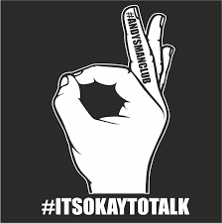
Andy’s Man Club
Web: http://andysmanclub.co.uk/
Email: info@andysmanclub.co.uk
The group meets every Monday (except Bank Holidays) at 7pm- 9pm at 3 locations:
Vale Circles, LS11 5JF
Milford Sports Club, LS5 3AS
Leeds College of Building, LS2 7QT

Andy’s man club offers a safe place for men to talk about issues and problems they are facing (or have faced) with other men in similar situations.

Paid Counselling
Phoenix Health and Wellbeing Centre
Web: http://www.phoenixhealthandwellbeing.org.uk/
Address: Phoenix Health and Wellbeing, Lower Ground Floor, 30 Park Place, Leeds, LS1 2SP
General counselling service. The initial session is £20 all subsequent sessions are £50. Also offer complimentary therapies such as workplace massage, aromatherapy, hot stone massage, acupuncture, Indian head massage, reiki.
Call 01132340818 or book online

Headspace Therapies
Web: https://www.headspacewellbeing.com/
Telephone: 0113 418 0212
Email: enquiries@headspaceleeds.com
We are highly experienced in offering therapy to clients struggling with difficulties in their life including the following:
Anxiety, depression, stress, panic attacks, relationship problems, marriage difficulties and divorce, family problems, work difficulties, low self-esteem, addictions, loss, bereavement, anger management, abuse, childhood and life event trauma, bi-polar/manic depression, phobias, obsessive compulsive disorder (OCD) and many other issues. Also included in Relationships and family section.
£48 per session

Mind Counselling service
Phone: 0113 305 5800
Web: https://www.leedsmind.org.uk/services/counselling/counselling
Email: info@leedsmind.org.uk
Offer an affordable self-referral counselling and psychotherapy service to people aged 18 and over who live in the Leeds area. Counselling is a short-term therapy option, compared to Mind Group Therapy which is a longer-term option. No couples counselling.
Sessions cost between £12.50 and £25 – how much you pay is dependent on your income. We are not able to offer sessions free of charge
Self-referral form online, Referrals open on the first Monday of each month at 4pm until we are at capacity. If this falls on a Bank Holiday this will be on a Tuesday.

General Wellbeing
Recovery College – LYPFT
Web: https://www.leedsandyorkpft.nhs.uk/advice-support/leeds-recovery-college/find-a-course/
Offer a range of training courses that focus on developing the knowledge and strength to overcome life’s challenges and live mentally and physically well.
It doesn’t matter if you have a diagnosis or not, our courses are open to all adults who live, work or study in Leeds and who would like to improve their mental health or personal understanding of mental health problems.
Courses include:
- Anxiety, Depression, Bi-polar, Psychosis, Trauma, Self-harm, Eating Disorders, gender identify, medication, housing, resilience, self-esteem, mindfulness, emotional eating.
See website for timetable.
Asylum seekers/Refugees: No Confirmation.
Has access to interpreters: No Confirmation.

Live Well Leeds
Web: https://livewellleeds.org.uk/
Phone: 0113 219 2727
Email: info@livewellleeds.org.uk
Address: Live Well Leeds, Support Centre, 53-55 Harehills Avenue, Leeds, LS8 4EX
Live Well Leeds is a mental health support service commissioned by Leeds City Council and NHS Leeds Clinical Commissioning Group (CCG) to work with adults aged 18+ (17+ if they are transitioning from children’s mental health services) who have mild to moderate mental health support needs and are registered with a Leeds based GP.
Live Well Leeds will deliver a range of services that include one to one support, group support, peer support, befriending and volunteering opportunities. All services will be based around a recovery, maintaining wellbeing and social inclusion.
Accept professional or self-referral through website or phone.

Linking Leeds
Phone: 0113 3367612
Email: linking.leeds@nhs.net
Address: The Reginald Centre, 263 Chapeltown Road, Leeds, LS7 3EX
Linking Leeds is the integrated city-wide Social Prescribing service for people in Leeds. Aim of the service is to signpost/support people to access services, groups and activities in the community that best meet their needs and will benefit their overall health and wellbeing.
Wellbeing Co-ordinators may support people to:
• A specialist mental health service
• General fitness or ‘get active’ classes
• Employment advice and volunteering opportunities
• Healthy eating or healthy walking groups
• Community, faith or cultural groups
• Support groups for physical conditions or emotional difficulties
• Money or housing advice services
• Creative groups including art, gardening or music
Wellbeing Coordinators are based within GP practices providing one-to-one support over the phone and face to face. Service is free.
Sleep Station
Web: https://www.sleepstation.org.uk/
Sleepstation is a clinically validated sleep improvement programme that can help you sleep better after just four sessions. Designed by experts and backed by science, our online sleep service is proven to combat even the most severe insomnia. Our team of coaches, doctors and sleep experts will help you identify the underlying causes of your sleep problem and provide the personal support needed to improve your sleep. We deliver remote care with a personal touch and that’s what makes our service so effective.
Through Sleepstation, you’ll have access to the most effective treatment available for insomnia - CBTi (cognitive behavioural therapy for insomnia). CBTi is more effective than sleeping pills and is recommended for even the most severe insomnia. Sleepstation’s online sleep improvement programme consistently helps people fall asleep faster, stay asleep longer and get better quality sleep.
Contraindications generally stem from the sleep deprivation aspect inherent in the sleep restriction technique used within CBTi. These include epilepsy, seizures, bipolar disorders, and those at high risk for falls. Please include a past medical history for anyone with PTSD or generalised anxiety. Patients with a personality disorder, schizophrenia or other psychotic spectrum disorders should not be referred to Sleepstation. We cannot accept referrals for patients who are under 18.
Asylum seekers/Refugees: YES
Has access to interpreters: NO
Leeds Adult Learning
Web: https://leedsadultlearning.co.uk/
Leeds Adult Learning offers a range of first step courses for adults. Courses take place across the city in a variety of different venues. Whether you are looking to learn a new skill, help your child or develop your skills to find work there will be a course for you. Many courses are free subject to personal circumstances - check with the course provider for details.
Examples include: English, Maths and ESOL classes, Job & Work Skills, Computing, Arts & Crafts and Health & Wellbeing.
Check their website for availability and for what’s on.

Men In Sheds
Address: The Environment and Business Centre, Merlyn-Rees Avenue, Morley, Leeds LS27 9SL.
Web: https://www.groundwork.org.uk/projects/men-in-sheds/
Phone: 0300 303 3292
Men in Sheds is a fully-equipped wood workshop for older men over 55 in Leeds. Please contact us for an appointment if you wish to join our waiting list.
Whether you’re experienced, want to brush up on your skills, or are completely new to woodwork.
The Shed is more than just a workshop, it’s a space to socialise, share skills and knowledge, or just have a cup of tea and a biscuit.

We operate every Monday, Tuesday, Wednesday and Thursday from 10.00am-4.00pm.
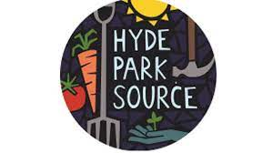

St Mary’s Community Rooftop Gardening Group
Address: St Mary's Rooftop Garden, St Mary's Court Flats, St Mary's Road (just off Chapeltown Road), Chapeltown, Leeds, LS7 3SB
Web: https://www.lyha.co.uk/st-marys-community-rooftop-gardening-group
LYHA has teamed up with community environmental organisation Hyde Park Source and their project Outdoors, Active & Well to deliver a year-round, weekly gardening group on our Community Roof-top Garden in Chapeltown.
This friendly group is open to LYHA customers, members of the local community and people from all across Leeds. Sessions range from growing all kinds of fruit, vegetables and flowers and learning new horticultural skills, through to outdoor cooking using the fresh food grown in the garden!
We encourage people, wildlife and nature to thrive in this wonderful hidden green space!
Why not come along to a session and give it a go?
The group runs every Friday from 2.30 - 4.30pm
To join the group, please contact the garden facilitator, Claire Doble at: claire@hydeparksource.org or call 0113 2458863

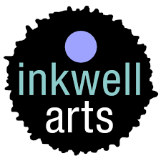
InkWell Arts
Web: https://www.leedsmind.org.uk/services/inkwell-arts/
Email: inkwell@leedsmind.org.uk
Inkwell Arts is the creative wellbeing service from Leeds Mind.
Through the arts, we support our community in discovering the link between creativity and wellbeing, helping them to look after their mental health for the long term.

Current Groups, please check website before directing clients:
Art group
Every Tuesday, 10am - 12pm
Inkwell Arts, 31 Potternewton Lane, Chapel Allerton, Leeds, LS7 3LW (From 17th May: Steinbeck URC Church, Steinbeck Road, Steinbeck Lane, Chapel Allerton, LS7 2PP)
£5 - all materials included. No booking necessary.

Felting group
Every Tuesday, 1pm - 3pm
Inkwell Arts, 31 Potternewton Lane, Chapel Allerton, Leeds, LS7 3LW (From 17th May: Steinbeck URC Church, Steinbeck Road, Steinbeck Lane, Chapel Allerton, LS7 2PP)
£5 - all materials included. No booking necessary.

Live Well Leeds Thursday Morning Art Class
Thursdays, 10am - 12pm
Inkwell Arts, 31 Potternewton Lane, Chapel Allerton, Leeds, LS7 3LW
For further details contact Leeds Mind 0113 3055800 or info@livewellleeds.org.uk, tel: 0113 219 2727

Live Well Leeds Friday Morning Art Class
Fridays, 10am - 1pm
Inkwell Arts, 31 Potternewton Lane, Chapel Allerton, Leeds, LS7 3LW
For further details contact Leeds Mind 0113 3055800 or info@livewellleeds.org.uk, tel: 0113 219 2727

Over 60s arts and crafts through the Royal Voluntary Service
Every Wednesday, 09:30am - 11:30am
Inkwell Arts, 31 Potternewton Lane, Chapel Allerton, Leeds, LS7 3LW
£4 per session - all materials included. Over 60s only. Booking required through the Royal Voluntary Service. Please call 0113 887 3597

Asylum seekers/Refugees: No Confirmation.
Has access to interpreters: No Confirmation.

