Social and Wellbeing Group
BAME WOMEN
Tuesdays 10am-11.30am
For A Healthy and Happy Life
- Physical and creative activities
- Meet new people
- One to one support
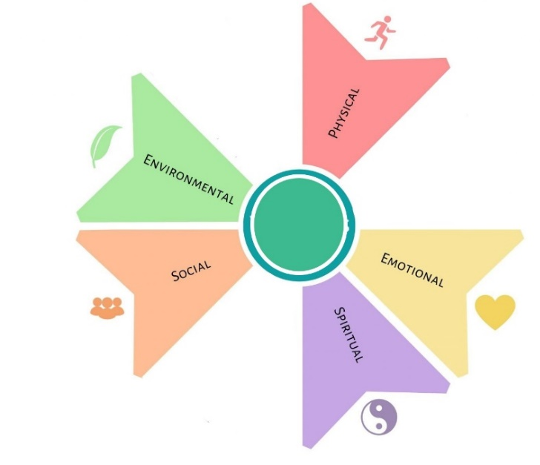
- Learn new skills

For further information contact Qudisia:
FAO Qudisia- admin@giveagift.org.uk
Phone: 0113 3805676
Give A Gift
Roundhay Road Resource Centre
233-237 Roundhay Road, Leeds, LS8 4HS

