MUSLIM WOMEN’S SUPPORT GROUP
Thursdays 10 - 11am

Faith is the source of hope, healing and growth.
Enjoy a weekly coffee morning meet up.
Connect, share and receive support and encouragement in a safe, spiritually nourishing environment.

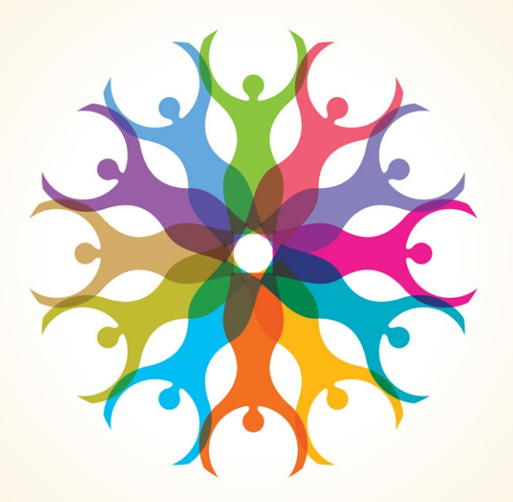

For further information contact Qudisia:
FAO Qudisia- admin@giveagift.org.uk
Phone: 0113 3805676
Give A Gift
Roundhay Road Resource Centre
233-237 Roundhay Road, Leeds, LS8 4HS

