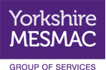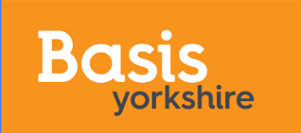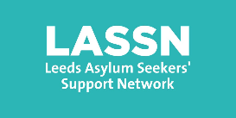

Leeds Solidarity Network
Over the last 5 years a group of organisations working with communities experiencing marginalisation and extreme inequality have come together to work in solidarity. The organisations -Leeds GATE, BASIS Yorkshire, LASSN and Yorkshire MESMAC work with Gypsies and Travellers, Sex Workers, Asylum Seekers and Refugees, communities affected by HIV and LGBTQ+ communities. Whilst the context of our organisations and the people we work for are different often the barriers and experiences of stigma are strikingly similar. We have identified that working together to demonstrate these common ways in which our communities are excluded can give us strength and help us to make systemic changes.
We have been working together to:
- Show support and kindness to each other as we face challenges in our work
- Celebrate our work
- Reflect and learn from our experiences of challenging injustice and developing allies
- Represent the experiences of all our communities in strategic spaces
- Come up with creative solutions that build systems and services from the margins not from the centre, recognising that accessible services work for everyone
To find out more about the theory, approaches and learning you can look through this interactive report on our work:
https://player.hihaho.com/f8ef7bf4-77dc-4bdc-876e-aa1834eecbd8
Health Communities Together
The Solidarity Network and colleagues in statutory health organisations including Leeds Public Health and Leeds CCG have come together to form a partnership which will seek to deepen our understanding, and take action on, the factors that lead to early deaths in our communities. From our deepening understanding we will develop a shared ownership action plan to move forward a whole systems approach to eliminating health inequalities. The work will be delivered in two phases:
Phase 1 – putting our communities in the lead, developing our relationships (one to one, as groups, through communications), deepening our understanding (researching, asset mapping, gaps analysis), honest conversations and facilitated spaces
Phase 2 – putting our communities in the lead, delivering system change projects to improve health outcomes for marginalised communities, developing a movement, allies and public support, learning and sharing from our work
We are looking for a staff member to join our team who is passionate about communities experiencing marginalisation being heard. We are looking for an individual who cares deeply about addressing health inequalities. We think you need to be a good communicator and flexible in your approach. You need to have strong skills in project management, facilitation and presenting information in accessible and creative ways. If this is you, we’d love to hear from you.
Join our movement, let’s make a change.

