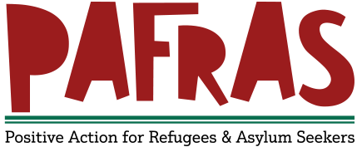
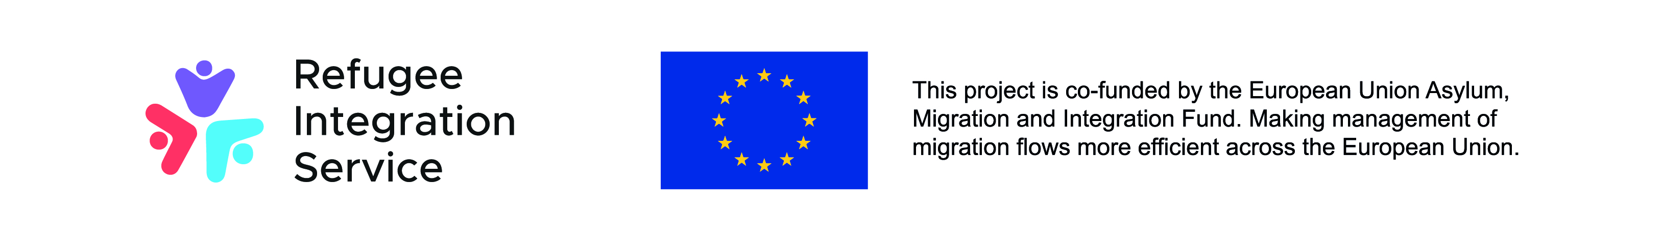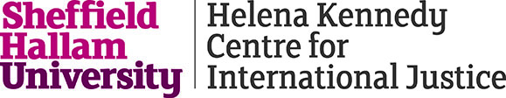

Positive Action for Refugees and Asylum Seekers (PAFRAS)

JOB DESCRIPTION

Refugee Family Reunion Worker – PAFRAS – FIXED TERM

Hours: 35 per week
Salary: NJC Scale 6 SCP 20 £25,991
Responsible to: PAFRAS Director
Employing body: PAFRAS Board of Trustees
Location: Homeworking, PAFRAS office and partner organisations.

This post is for a fixed term until January 2022.

You will sit within the PAFRAS team, delivering this discrete piece of work, in partnership with the Helena Kennedy Centre Refugee Rights Hub.

PURPOSE OF THE JOB

You will provide clients with specialist legal support, advice and representation in refugee family reunion and refugee family reunion related settlement applications. You will provide a consistently high-quality standard of casework, working mostly self-sufficiently, and may undertake additional duties as required. This may include working in other sites across Yorkshire and the Humber (travel and associated costs will be covered) and tasks associated with research and policy development.

You will ensure compliance with any relevant regulations and accreditations.

MAIN DUTIES AND RESPONSIBILITIES

- To deliver specialist legal support, based on an in-depth knowledge and understanding of law, policy and practice relevant to the Refugee Family Reunion.

- To support the delivery of a unique Yorkshire and Humber wide project.

- To undertake what can often be complex family reunion and settlement casework up to and including lodging appeals and applying for Exceptional Case Funding ( ECF )

- To undertake triage of initial instructions from potential clients and stakeholders and providing initial advice and signposting based on triage outcomes.
- Interview clients, check for eligibility and offer advice on the process and evidence required to progress their legal matter.

- Maintain and create enquiry/data management systems and records and assist with the preparation and completion of statistical reports and case studies.

- Assist in completing online and paper forms relevant to RFR and SET(P) applications and ECF.

- Help clients compile bundles of evidence, witness statements and cover letters.

- Safely and securely signpost clients and refer to other relevant agencies following on from relevant decisions

- Attend project team meetings with the project team at Helena Kennedy Centre Refugee Rights Hub as and when required.

- Contribute ideas and suggestions to enhance service delivery and customer experience.

- Manage the implementation of policies and procedures in functional areas, providing advice on these and ensuring their effective communication.

- To maintain confidentiality and treat sensitive issues with appropriate tact and diplomacy, working in accordance with data protection legislation and any other regulations relevant to the area.

- To develop and deliver training to promote awareness of the service.

GENERAL

- To work at all times as part of a team. This includes working with other staff in PAFRAS, attending team and staff meetings.

- To work flexibly in accordance with the needs of the Service, including undertaking out of hours work as required.

- To maintain flexibility and liaise with the line-manager and team regarding service cover and other duties agreed with the line manager.

- To be inducted, supervised, performance monitored and appraised in line with the organisation’s performance management policies and procedures.

- To be responsible for personal learning and development where appropriate and undertake training, both mandatory and optional, to increase knowledge, skills and awareness

- To provide monitoring information and reports as part of funding and organisational requirements and for the Board of Trustees as requested by PAFRAS management.

- To participate in the further development of the service and organisation in conjunction with line manager, as requested.

- To be aware of and employ the general practices of PAFRAS’s Health and Safety policy and ensure these are adhered to at all times

- To operate within the aims, policies and practices of PAFRAS.

- Promote the aims and objectives of PAFRAS.

- To provide information about PAFRAS to people/agencies interested in the organisation’s work.

- To undertake any other duties as directed by the line manager, in line with the responsibilities of this post.

Essential role specific requirements

- Qualified at least to OISC Level 2 (asylum and protection only as a minimum) or IAAS level 1 (We would consider those who have recently sat the Level 2 assessment and are awaiting their grades)
- Experience of the refugee family reunion and refugee settlement application processes and wider refugee related casework
- Experience of working with clients using an interpreter
- Significant experience of developing a caseload of clients and effectively managing a legal caseload.
- Understanding and experience of working under the OISC rules, codes and standards
- Excellent written and oral communication skills
- At least one year of providing legal advice to clients
- Excellent IT skills
- Experience of working in a fast-paced environment with conflicting and competing demands
- Commitment to PAFRAS aims and values
- Commitment to respecting diversity and anti-discriminatory/anti-oppressive practices
- Commitment to personal responsibility and promoting this with other people.
- Commitment to personal development, learning and reflective practice.
- Open to change in line with the needs of the service/organisation.
- A commitment to working in partnership with service users.
- Willingness to be managed and supervised.
- An ability to work flexibly according to needs of the service.
- Commitment to team working.
- Ability to keep confidences (within the policy of the organisation).

Desirable role specific requirements

- Experience of the CLIO case management database
- Experience of refugee policy related work
- Experience of research in the refugee sector

