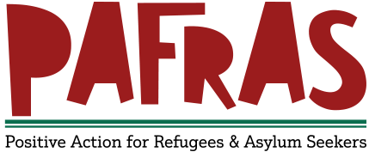
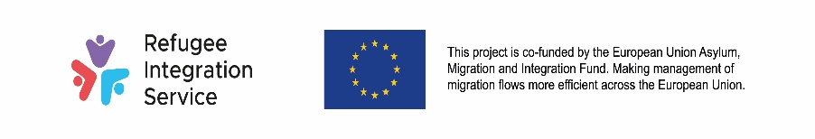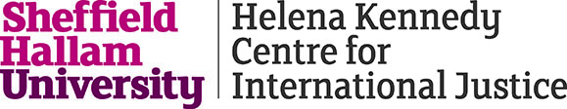

REFUGEE FAMILY REUNION CASEWORKER

We are currently looking to recruit an experienced Refugee Family Reunion Caseworker who will sit within the PAFRAS team, delivering this discrete piece of work.

The post holder must be registered at OISC Level 2 (Asylum and Protection minimum) (or awaiting grades having recently sat the OISC L2 assessment)

PAFRAS is a grassroots charity, embedded in the local community, which has been supporting asylum seekers in Leeds since 2002 whether they are single people, couples or families with children. Our aim is to support people to find safe and sustainable routes out of destitution. Ultimately, we are ambitions for migrants in Leeds and want to support them to become leaders in Leeds, and beyond.
We are a small and passionate team working in a challenging environment with the support of communities, partners, an incredible volunteer team and a dedicated supporter base.
Our work has three main strands;

- immediate humanitarian relief and emergency support
- OISC accredited advice and advocacy aimed at assisting service users to make lasting improvements to their situation
- mental health and well-being assessments and support

We also have our Young Migrants Matter project, which offers intensive support to young migrants, 16-24 years old, with insecure immigration status.

We are delighted to be entering an exciting new partnership with Helena Kennedy Centre Refugee Rights Hub* through a two year project that seeks to expand the provision of high quality advice and support to refugees across Yorkshire seeking reunification with loved ones they have been forced to leave behind.

The project will start in January 2021 and will provide free at the point of use advice and support to refugees across Yorkshire. An in-house solicitor, based at the HKC Refugee Rights Hub will support the wider project and undertake appeals and strategic litigation to further define and improve policy, practice and case law.

Sheffield Hallam University established its’ Refugee Family Reunion Clinic in September 2018 and has gone from strength to strength in developing a way of supporting refugees through the often complex processes with support from both it’s under graduates and post graduates.

The work is both challenging and rewarding and the successful candidate will be able to partake in interesting training and unusual networking opportunities and contribute to the development of bespoke tools that will both raise awareness of the key issues relating to refugee family reunion and enable wider understanding of making and supporting applications.

This will be whilst also enjoying the benefits of working at PAFRAS, where you will be part of a small, supportive, knowledgeable and passionate team. You will receive generous annual leave entitlement, flexible working practices and access to an employee assistance scheme. PAFRAS are a Mindful Employer.

Salary: NJC Scale 6 SCP 20 £25,991
Hours: 35
Employing body: PAFRAS

For an application pack please visit: www.pafras.org.uk

Please return your completed application form to recruitment@pafras.org.uk no later than 3rd January 2021. Interviews will be held on 8th January 2021.

Informal enquiries regarding this job can be made by telephoning the Director, Karen Pearse, on 0113 2622163

PAFRAS is committed to promoting equality of opportunity for all and to developing a diverse and talented workforce. We encourage applications from people with lived experience as a refugee.

Registered Charity Number 1120950

