Community Matters Yorkshire is offering free online courses.

- Introduction to fire safety in the workplace
- Managing conflict
- Self Awareness and personal development
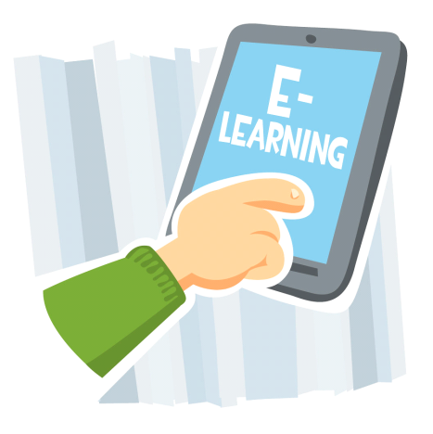
- stress management
- team working
- Health and safety
- manual handling
- safeguarding children
- food safety
- introduction to allergens
Free to anyone who is economically inactiveWork or claiming benefits.
wORK from home at your own pace. All you need is a tablet or a computer and a link will be sent to your personal email address.
On completion you will receive a certificate from awarding body - Highfield Group.
email ADELE.COOPER@COMMUITY-MATTERS.ORG.UK
OR PHONE 07718651259 FOR FURTHER INFORMATIOn
