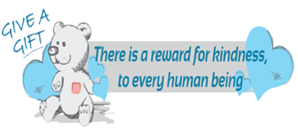
Ladies
Social
Group

Every Tuesday between 11.30-1pm

Meeting point-Give a Gift office, The Roundhay Resource Centre, Roundhay Road, Leeds, LS8 4HS

A group ran by women for women

A chance to meet new friends and socialise with new
activities every week

If you would like more information and are interested in attending,
English speakers contact Hana 07951455172
Arabic speakers contact Hala on 07403556817

