Style Sheet for Leeds Migration Partnership
All the following resources can be found in this folder Download link

LMP Logo

Typeface/font:

Header: Patua One Download Link
- Colour: Black (Hex: #111111 or Aubergine (Hex: #231523)

Body text: Open Sans Download Link

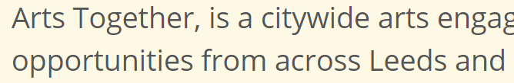

Colour scheme

Logo colours
- Yellow: #EBC318
- Dark Blue: # 39797F
- Orange: # F16522
- Aubergine: #231523

Background Colours
- Sky blue: #BED4DF
- Sand yellow: #FEF9E5

Powerpoint
Use the LMP Powerpoint template. This is preloaded with the colour scheme and fonts, and should make your life a lot easier

