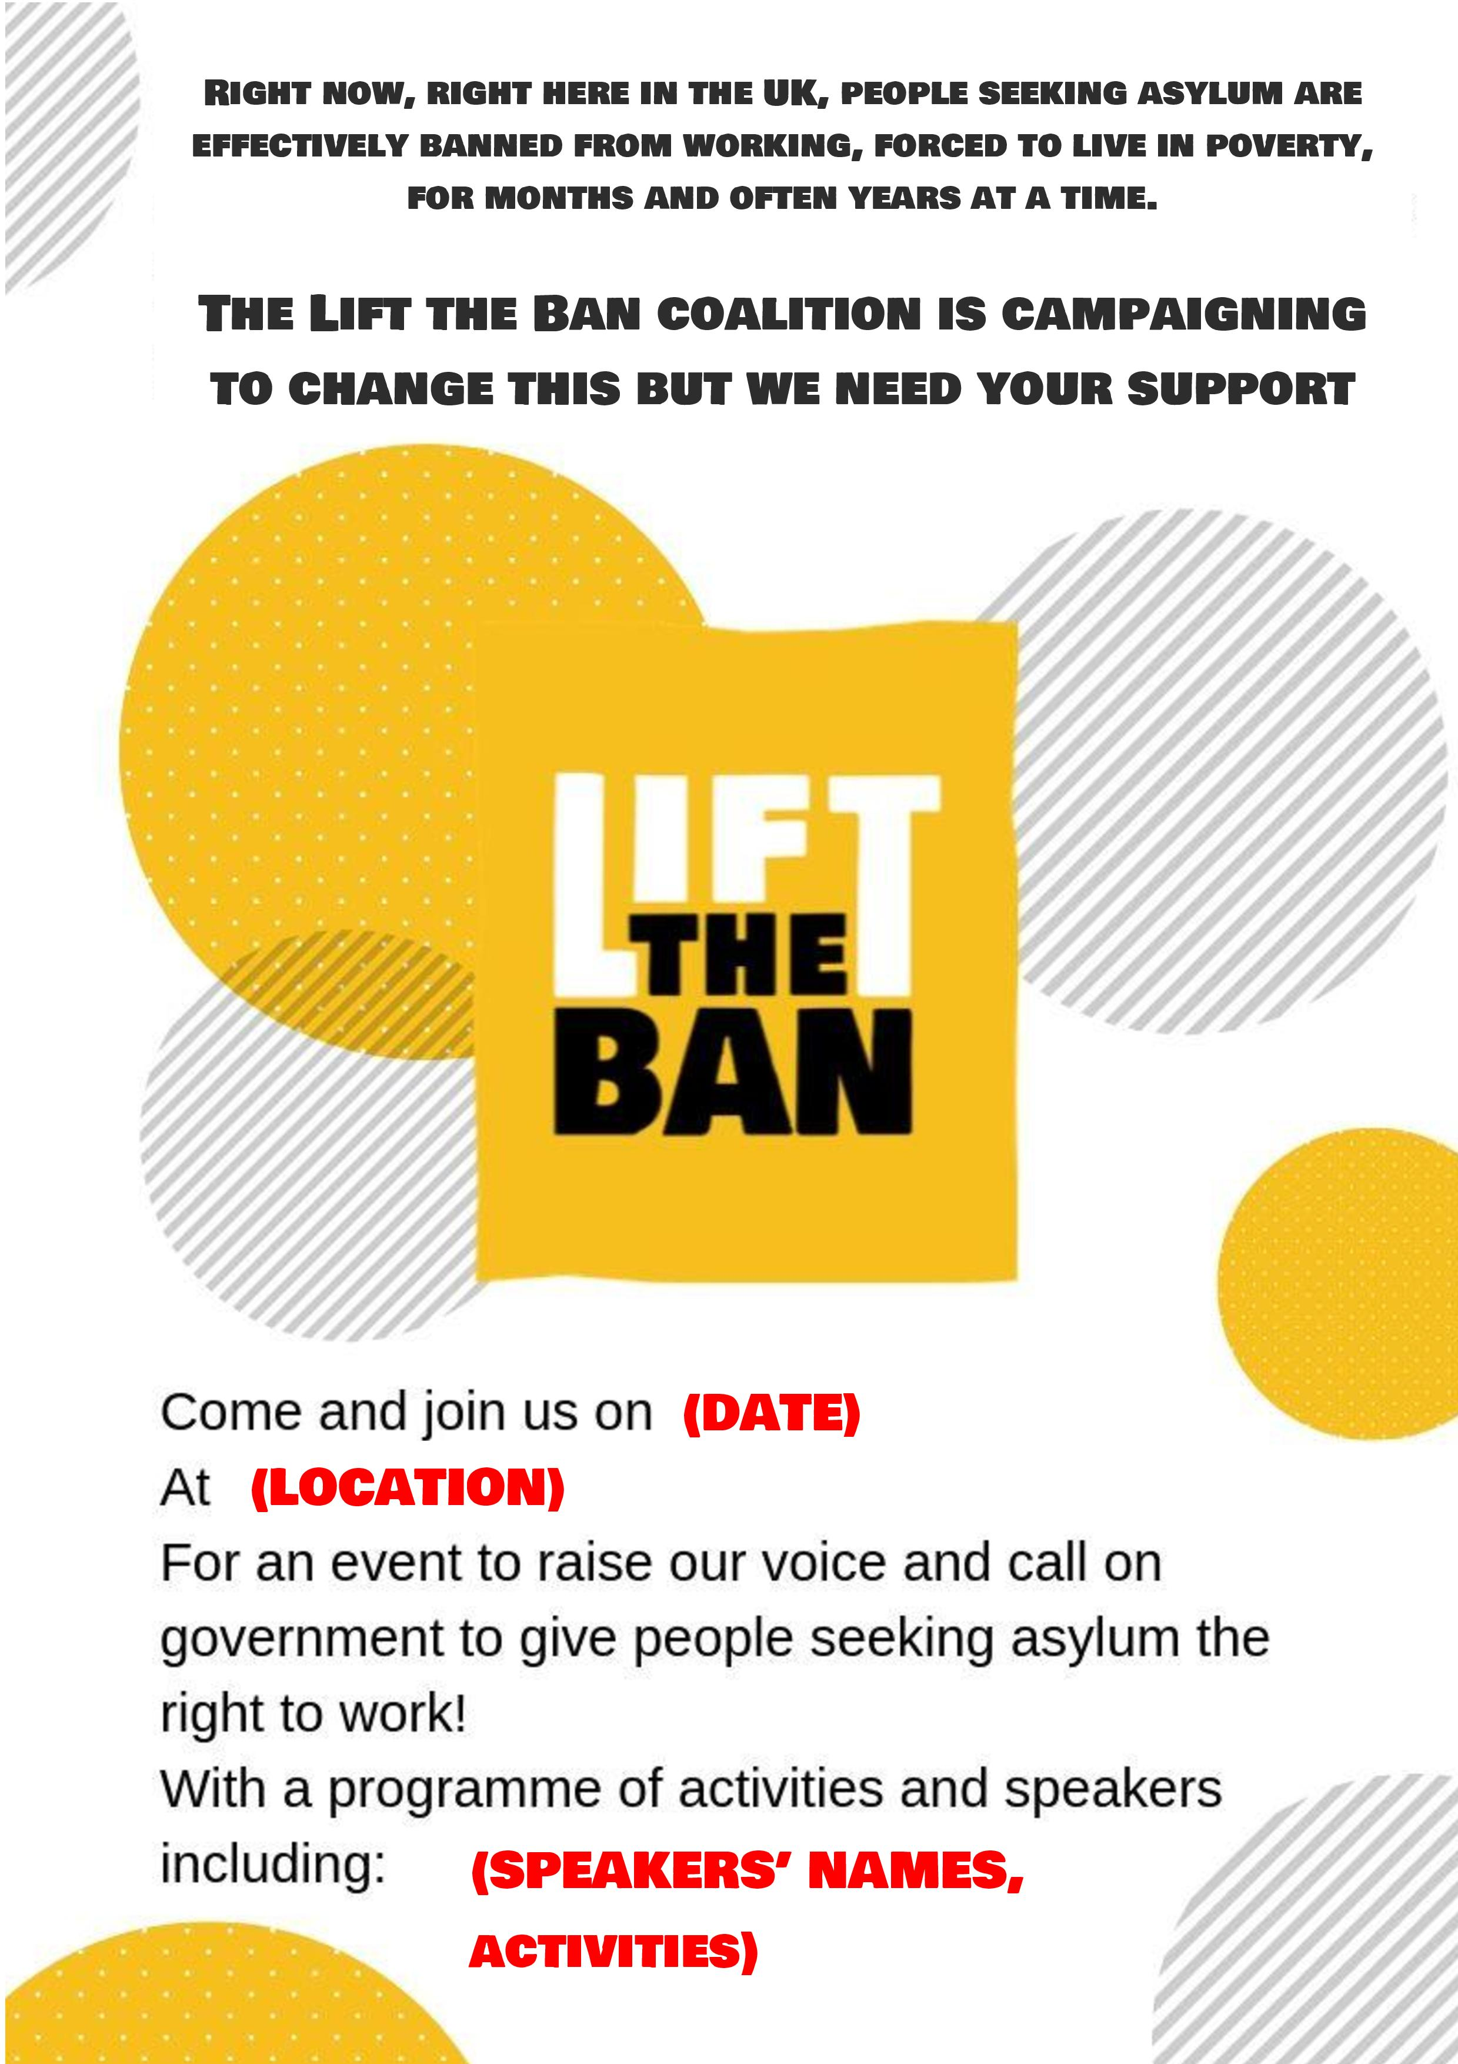

**Thursday 4th July at 2pm**

**Alex Sobel MP, Councillor Jonathan Pryor, poems by Right to Work campaigners**

**Leeds Kirkgate Open Market**

