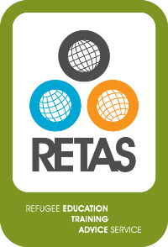
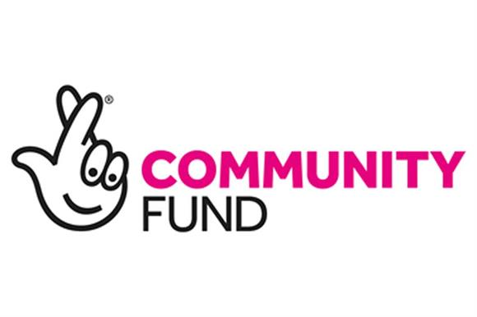

RETAS Leeds

Job Description and Person Specification

Job title | Education and Employment Adviser
Location | RETAS Leeds, 233-237 Roundhay Road, Leeds, LS8 4HS
Hours/salary scale | 35 hours per week, £23,398 per annum
Responsible to: | Operations and Development Manager
Fixed Term post funded by the Big Lottery Community Fund | April 2019-Sept 2020 (Post subject to regular review in line with financial monitoring of the projects)
The Refugee Education Training and Advice Service (RETAS) is a well-respected and established charity in Leeds, which provides support to refugees and asylum seekers in West Yorkshire. We work in West Yorkshire, with asylum seekers and refugees, to provide advice and assistance across a wide range of issues, including helping asylum seekers through the complexities of the asylum system, addressing issues of destitution and assisting refugees and asylum seekers to access key services including housing, welfare benefits, health, education and employment. Our teams work with relevant agencies including the Home Office, Refugee Community Organisations, Local Authorities, Legal Service Providers, Housing Providers, Health Institutions, Job Centre Plus and other mainstream service providers.

RETAS are looking to recruit an Education and Employment Adviser, based in Leeds, to support our work on our Big Lottery Community funded 28-day Transition Project which will support asylum seekers who have very recently been granted refugees status to transition successfully from living in Home Office accommodation to living independently in alternative accommodation, and ultimately to integrate successfully into local communities. The Adviser will also support the Operations and Development Manager in the delivery of RETAS’ responsibilities to its clients and to support their social and economic integration.

This is an excellent opportunity for an energetic and proactive individual who has a passion and desire to support asylum seekers and refugees.

Job Overview:

- To plan and deliver one-to-one and group educational and employment advice services
- To help deliver an intensive 28-day programme of advice and practical support to refugees with newly granted refugee status in the Leeds area.
- To support clients to access ESOL and other opportunities that aid integration.

DUTIES AND RESPONSIBILITIES

- Plan and deliver RETAS’ client one-to-one services, including drop-ins and offsite advice sessions
- Provide advice, support, and advocacy to individual refugees and asylum seekers in the areas of education, training and employment in the RETAS Leeds office and in other outreach locations within the region. Advice will include:
- Employment advice: refugee rights to employment; assistance with CV applications; liaison with employers, job centres and employment agencies; coaching and preparation for job interviews; helping with job application forms; finding appropriate placements; referring to other agencies
- Education advice: refugee rights and entitlements; eligibility for statutory grants and other sources of funding; finding places in suitable training schemes and on courses of study in English language, and in adult, further, and higher education institutions including navigating the UCAS application process.
- 28 Day Transition period advice: accommodation advice, referrals, visits and signposting; securing appropriate identity documents and NINO; setting up bank accounts and email accounts; registration with Jobcentre Plus for Jobseeker’s Allowance (JSA), Employment and Support Allowance (ESA), Income Support (IS),Tax Credits and Child Tax Credits, Child Benefit and Local Councils for Housing Benefit & Council Tax Support; registration with GPs and schools etc; professional and vocational advice; referrals to wellbeing organisations, foodbanks, mental health services, Victim support groups and assessment for English classes; develop a post transition Action Plan for individual clients which outlines the pathway of continued support to clients as registered users of RETAS services.
- Design and deliver training and awareness-raising opportunities/ provide information to clients on education, employment & benefits, and integration-related topics
- Identify need for services within the region and determine how best to access refugee/migrant communities
- Carry out research to provide clients with accurate and up-to-date information
- Contribute to the development of cross-referral arrangements within the network of refugee organisations and service providers.
- Deliver RETAS’s outreach activities, networking and working in partnership with organisations to deliver services outside RETAS offices
- Record client information using relevant databases and other record keeping systems
- Record client outcomes, helping develop systems for maintaining contact with clients after service completion
- Train, supervise, and support volunteers on and offsite
- Identify/create new volunteering opportunities
- Help arrange and monitor work placements
- Contribute to funding bids
- Ensure proper monitoring and reporting of work carried out on projects including careful tracking of the progress of individual clients referred to each project
- Support the Operations and Development Manager of RETAS in ensuring a high standard of reporting to funders and any other independent evaluations

Person Specification
Detailed below are the types of skills, experience and knowledge which are required of applicants applying for the post. The “Essential Requirements” indicate the minimum requirements, and applicants lacking these attributes will not be considered for the post. The points detailed under “Desirable Requirements” are additional attributes to enable the applicant to perform the position more effectively or with little or no training. They are not essential, but may be used to distinguish between acceptable candidates.
Skills, Experience and Knowledge  In the spaces below please detail your skills, experience and knowledge along with other evidence to show how you meet the essential and desirable requirements of the role. | Essential | Desirable
An empathy for, and an understanding of, situations facing refugees and asylum seekers; particularly those living in West Yorkshire | x
Commitment to the client centred approach of the organisation | x
Understanding of, and experience in, supporting refugees in overcoming the multiple barriers to integration (with specific focus on access to education, employment and training) | x
Good knowledge of agencies offering services relevant to refugees or who work directly with employers in the region | x
Comfortable with public speaking, advocacy, networking and delivering courses/presentations | x
Creative person with the ability to launch new initiatives | x
IT literate | x
Experience of monitoring, reporting and evaluating project outcomes | x
Well organized, friendly, ability to work under pressure and experience of working with project deadlines | x
Experience of working with volunteers | x
Ability to work remotely from the team | x
Happy to work in a close-knit team and able to encourage and support other staff members in their service delivery | x
An understanding of the asylum process and the barriers facing refugees during the 28-day-move on period from asylum support | x
Information, Advice and Guidance qualification |  | x
Fluent in a language relevant to refugees |  | x
Good knowledge of community organisations in Leeds |  | x

