Leeds DEC would love to invite you to a FREE LUNCH to discuss if we can work with you…

Do you have understanding /experience / links in the area of
refugee / asylum issues?
Could you collaborate with our teacher groups to develop teaching resources to help young people understand refugee issues more deeply?

Leeds DEC is a small charity that has been working with schools in West Yorkshire for over 40 years helping children and young people to understand how they interact with the world as Global Citizens and to support them in making positive choices. We are currently working with groups of teachers to produce teaching resources on Global Learning linked to the curriculum in Maths, Sciences, RE / Citizenship and Languages at Secondary level.

Our teacher groups have identified refugee / asylum / migration issues as one of the key areas they would like to develop activities around. We would love to collaborate with people with experience in this area.

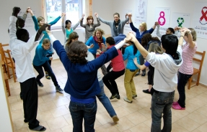
What we’re hoping to achieve:
- A better understanding among young people in our secondary schools of asylum and refugee experience
- Our young people to develop the capacity to challenge myths and stereotypes about asylum
How you can support us:
- You have the contacts to gather case studies which will enrich the teaching resources we produce
- Your lived experience can challenge us to consider different angles and perspectives which will enable our teachers to develop better resources
How we can support you:
- We have 40 years of experience working in schools in West Yorkshire and, if you are interested in working in the education sector in the UK, we can offer you direct experience in collaborating with teachers
- You and your organisation can use the exciting new resources we develop together!
We would love to invite you to lunch at Bridge Street on Monday 11th March 12.30 – 2pm to discuss how we can work together on this! Please let us know if you can come by emailing sarah@leedsdec.org.uk so that we can make sure we have enough food! Get in touch if you need further directions / info. Hope to see you there.

