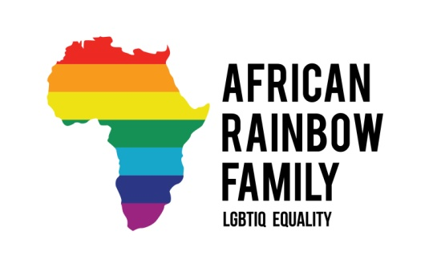
African Rainbow Family
A World Without Prejudice
Providing counselling ,financial, training and housing support for the Lesbian, Gay
Transgender and Intersex community and refugees.
Email:info@africanrainbowfamily.org Web: http://africanrainbowfamily.org/
Tel: 07711285567 @AfricanRainbow1 Facebook: AfricanRainbowFamily

REFERRAL TO AFRICAN RAINBOW FAMILY

Please fill in as much detail as possible. This will help us to assess any level of support needed quickly. Please also attach any relevant documents that might assist us.

Once completed send the referral by:

- Email: info@africanrainbowfamily.org

All referrals are considered and response given as quickly as possible.

CONFIDENTIAL

Client Name:

Address:

Telephone Number:

Email:

Referral agency
Your Name:
Organisation:
Telephone number:
Email address:
Can we contact the client directly?

Country of Origin/English speaking?

Date of birth:

Date of referral:

Have you been a member of African Rainbow Family before?

Are you a person who is seeking asylum? Yes/No

- Is an interpreter needed? Yes or No

- If so, which language?

DETAILS OF THE REFERRAL

ELIGIBILITY

To assess whether you are eligible for support you will need to identify as a lesbian/gay/bisexual/transgender/intersex or queer?

Thank you for completing the form. Please ensure all relevant documents are attached to assist to assess the referral.

Please email completed form to info@africanrainbowfamily.org

