Leeds Migration Partnership – Strategic Group priorities and core activities, April 2018-March 2019
Priority 1: Safety and inclusion
City wide strategic outcome |  | All migrants will feel safe
Description | City response | LMP objectives – core things to deliver
This outcome is about listening to how safe migrants feel and ensuring Migrant and Refugee sector, generalist and statutory services have the knowledge and skills to be able to recognise, respond to and challenge issues of safety within migrant communities. This outcome is also about monitoring the hostile environment driven by Home Office policy and how this impacts on the ability to report crime, seek help and feel included.  Areas to consider in this outcome are:  - Human trafficking and Modern day slavery  - Hate crime  - Domestic violence  - Exploitation  - Safeguarding (children, young people and adults) | City strategies this links to:  Leeds Hate Crime Strategy  Leeds Domestic Violence and Abuse Strategy  West Yorkshire Police and Crime Plan  Forums/task groups that LMP lead(s) may want to attend or present at:  Hate Crime Strategic Board  Operational Hate Crime Group  Human Trafficking Meeting/Forum?  Leeds Domestic Violence Forum  Hope for Justice | Leeds to be aware of the safety issues important to migrants and be ready and prepared to respond to these effectively. We will do this by;  - Identifying key providers, strategies and networks linked to and leading on human trafficking, domestic violence and safeguarding  - Promoting stronger links between migrant communities, services, strategies and networks and those linked to/leading on human trafficking, domestic violence, safeguarding issues  - Facilitating awareness raising opportunities relating to human trafficking, domestic violence, safeguarding and migration  - Influencing policy and practice relating to safety and inclusion  - Gather evidence of the need and impact to influence policy, identify unmet needs  - Facilitate conversations within migrant communities and build capacity to ensure the voice of communities influence policy and practice  - Make recommendations to Leeds Strategic Migration Board and other relevant boards and organisations  - Access/sign up to the Leeds Domestic Violence Service (LDVS) Quality Mark  - Creating a measure to identify that we are providing a better service to migrants who are affected by these issues (eg: a ‘where are we on a scale of 1 to 10 and are we heading in the right direction)

Priority 2: Housing and homelessness
City wide strategic outcome |  | All migrants will have somewhere to live
Description | City response | LMP objectives – core things to deliver
This outcome is about tackling inequalities in housing, disproportionate levels of homelessness amongst migrant communities compared to the wider population of Leeds and the demand, quality and standards of the properties available to migrant communities.  Areas to be considered for this outcome are:  - Asylum accommodation  - Property availability for Refugee move on and Family Joiners  - Destitution and  - Access to Housing Benefits and universal Credit. | City strategies this outcome links to:  Leeds Housing Strategy  Leeds Growth Strategy  Leeds Financial literacy and financial inclusion strategy  Forums/task groups that LMP lead(s) may want to attend or present at: | To end destitution among migrants living in Leeds. To achieve this LMP will;  - Use contacts within NACCOM (No Accommodation Network) to explore the approaches to ending homelessness among migrant communities including those with no recourse to public funds other regions have in place and identify good practice, innovation and solutions that Leeds can learn from and implement  - Join Leeds Homelessness Forum, present to the group and aim to shape the Leeds Homelessness Strategy to include a positive commitment to supporting migrants and those living in the city with no recourse to public funds  - Share the voice and experiences of migrants who have lived in destitution and homelessness with the wider sector, decision makers and Leeds Strategic Migration Board (LSMB) and gather evidence of the need and impact to influence policy, identify unmet needs and make recommendations to LSMB  Appropriate accommodation of a good standard is available at the time of need for migrant communities. To achieve this LMP will;  - Set-up a cross sector working group with members of DWP, Housing Options, third sector and those with lived experience to identify barriers to a smooth move-on for Refugees during the 28 transition period. Make recommendations to LSMB and local and national decision makers.  - Gather evidence to support the recommendation of the APPG Inquiry to increase the move-on period from 28 to 50 days, share the evidence with Asylum Matters and support campaigns to influence decision makers and policies.  - Identify an early action model that can better prepare Local Authorities, mainstream systems and processes to receive Family Joiners, the Syrian Resettlement Programme is an example of a model that prevents homelessness for new migrants.  - Gather evidence of the standard and appropriateness of accommodation migrant communities are living in, support refugees, asylum seekers and other migrants to share their experiences with decision makers including local MPs, Home Office and Local Authority.  Housing and Homelessness linked to migrant communities and living conditions (social isolation)

Priority 3: Health
City wide strategic outcome |  | All migrants will have healthier lives
Description | City response | LMP objectives – core things to deliver
This outcome is about ensuring the health priorities of migrants are listened to and shared across the City’s health plans.  This outcome is also about tackling health inequalities and taking steps to improve access by challenging policy, raising awareness and equipping migrant communities with the knowledge to make informed decisions for themselves and their families.  Areas to be considered for this outcome are:  - Healthcare charging  - Access to health services  - Mental health  - Maternity care  - Public health  - Sexual health  - Food poverty/malnutrition  - Substance services | City strategies this links to:  Leeds Health and Well-being Strategy  Better Lives Strategy  Forums/task groups that LMP lead(s) may want to attend or present at:  Leeds Health and Well-Being (HWB) Board  Leeds Migrant Health Board (LMHB)  Refugee and Asylum Seekers Mental Health (RASMH) Network  Health Watch Leeds  Maternity Health  Food Aid Network | LMP  - to help members understand how health key players operate in the city  - to identify members who will engage with the key forums mentioned in the City Response  - to encourage reps to other members know that they attend  - to ensure members know how to influence things being discussed at these meetings  - to understand health commissioners role and how to influence them  LMP to support local NHS partners in providing clear unambiguous information on  - health charging for Staff and migrants alike  - GP registration for Staff and migrants alike (and collate evidence of good/poor practice)  LMP to ensure Food Aid Network is promoted to all members, in order to maximise uptake of free food provision by migrant communities  Support NHS partners with collation of evidence and data  [as a generic objective that could be included in all priorities: to ensure that LMP has a way to feedback on all the city responses]

Examples of ways LMP Members can influence change
City wide strategic outcome | All migrants will feel safe
City wide strategic outcome | All migrants will have somewhere to live
City wide strategic outcome | All migrants will have healthier lives
Leeds Health and Well Being Board: current priority is clarity on charging.
- Help plan/organise the event on charging
- Attend event on charging
- Gather info on effects of charging on client group

Food Aid Network: promote food banks and free food provision to all relevant clients

GP registration:
- Ensure clients know their rights about GP registration and advocate on their behalf where possible
- report any difficulties with GP/Dental registration to CCG commissioner who will deal with them personally at Practice level
- cc Healthwatch in

Support NHS partners with collation of evidence and data:
- no current requests

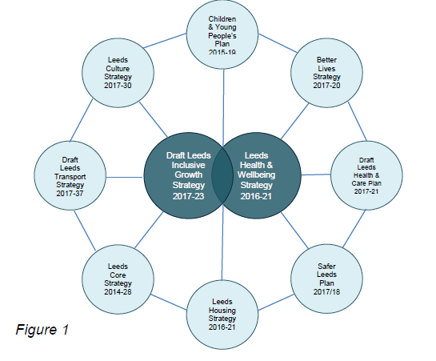
Figure 1 extracted from Best Council Plan 2018/19 to 2020/21 Report to Executive Board 7 February 2018 – identifying key strategies for the city that migration issues are linked to

