RETAS
233-237 Roundhay Road,
Leeds, West Yorkshire
LS8 4HS
Adult Learning Timetable September 2018
Enrolment dates: 10-3.00pm Mon 3rd , Tues 4th, Wed 5th Fri 7th Sept. Classes start w/c 10th September
September 2018
Please bring proof of benefits or ID For more information call 0113 380 5630

Monday | Tuesday | Wednesday | Thursday | Friday
ESOL Entry 2  9.45am – 12.15pm | ESOL Entry 3  9.45am – 12.15pm | Pre Entry ESOL  9.30am – 12.00pm | ESOL Entry 1  9.30am – 12.00pm | Reading and writing  9.45am – 12.15pm
 | ESOL Entry 1  9.30am – 12.00pm | Read & Write  10-12pm
Pre Entry ESOL
9.30am – 12.00pm

ESOL Entry 3  1.00pm – 3.30pm  ESOL Entry 1  1.00pm – 3.30pm | Pre Entry ESOL  1.00pm – 3.30pm | Social conversation  1.00-3.00pm | Pre Entry ESOL  1.00pm – 3.30pm
ESOL Entry 2
1.00pm – 3.30pm

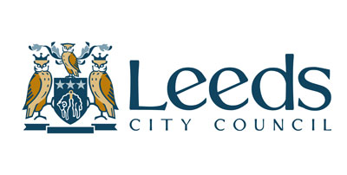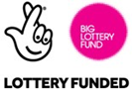
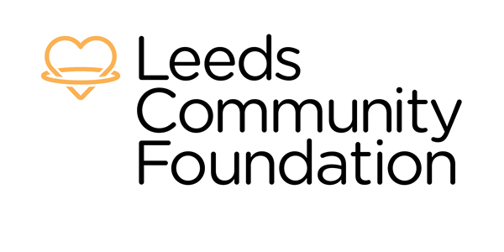

St Anne’s Adult Learning: Course Information
Courses are FREE if you are on benefits, asylum seekers or refugees

ESOL (English for Speakers of Other Languages)
There are three levels of classes: Pre-Entry for those with no English, Entry 1 for those with basic English communication skills,
Entry 2 for those who can communicate at a reasonable standard and Entry 3 for those who are confident communicators.

All ESOL classes are based on the national standards for adult literacy and numeracy developed by the Qualifications and Curriculum Authority (QCA).
The overall aim is to improve speaking, listening, reading and writing from Pre-Entry Level to Entry 3 proving learners with skills, knowledge and understanding that they need to successfully function in everyday life. It covers a range of topics including Health and Welfare, Money, Environment, Education, Work, and Digital Skills. and provide progression opportunities for learners. Classes will allow learners to learn practical skills such as:
Giving personal information; talking to health professionals, teachers and government officials; reading letters and leaflets from schools, benefit offices, housing and government agencies, banks; asking and answering questions from professionals; completing forms with personal information; engage in social conversations about culture

Reading for everyday life
This course will help to improve confidence and develop basic reading and understanding skills. It is open to any learner from pre-entry to Entry 3 level. The reading skills covered will include: basic punctuation; reading and obtaining information from signs, pictures and written text; commonly used/high frequency words; and reading and responding to formal texts. It includes core outcomes around sharing personal information and basic numeracy.

Writing for everyday life
This course will help to improve confidence and develop specific writing skills in everyday life. It is open to any learner from pre-entry to Entry 3 level. The writing skills covered include: handwriting, spelling and punctuation; writing notes, letters and emails; filling in forms; writing short/simple narratives; making written records from oral dictation. It includes core outcomes around sharing personal information and basic numeracy.

Social Conversation
This course will help to improve confidence and develop skills in communicating in social situations. It is open to learners from Entry to Entry 3 level. The language covered will include: making small talk; asking for things; giving opinions; agreeing and disagreeing; giving advice; responding to personal questions; expressing feelings and needs. It includes core outcomes around sharing personal information and basic numeracy.

General information for all courses
These are all first step courses to give learners the confidence and skills to do further courses and gain qualifications in future.

Courses last 6 weeks and learners will attend one class per week for 2.5 hours. We provide learners with information
about where to continue their learning when courses finish. Classes are small with between 8 and
12 learners. Learners need to be 19 years or older. Learners should attend every session. If classes fall below 8 learners for 2 consecutive weeks, they will close.

For further information call Deborah on 0113 3805630 or email deborah@retasleeds.co.uk

