 | Vulnerable client referral Form 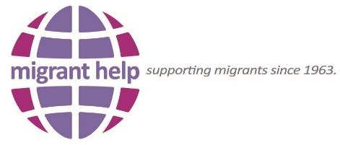
 | ReferrING agency
 | Name of Referrer
 | Tel No: | Date of referral:
 | Service User details
 | Name:
 | Address:
 | Tel No:
 | Language:
 | Family Status (please tick): Single Family
 | Gender:
 | Additional Information: (please list any vulnerabilities)
 | What support if any your organisation is providing to the person/s?
 | Reasons for referral: (please provide brief description of nature of assistance required).
 | Home office/Port Reference (if known):
PLEASE RETURN
By Email:
iaAdminWakefield@migranthelpuk.org By Fax: 01304 800 319

 | FOR INTernal use only
 | DATE RECEIVED:
 | Date actioned:
 | Case worker :

Who can you refer?
An asylum seeker at any stage of the asylum process who is vulnerable or is experiencing difficulty accessing or engaging with our free Helpline.

Definition of vulnerability

Migrant Help defines a vulnerable person as:

- A disabled person;
- An elderly person;
- A pregnant woman;
- Lone parent with a child;
- A person who has been subjected to torture, rape or other serious forms of psychological, physical or sexual violence;
- A victim of human trafficking;
- A minor;
- Any person identified in 1-7 above who has had an individual evaluation of their situation that confirms they have special needs;
- A person that has an inability to access services by website or telephone advice line.

