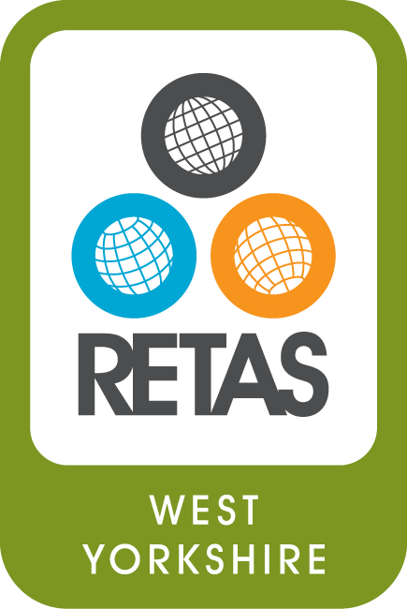
RETAS Leeds

Job Description

RETAS Operations and Development Manager

Salary and contract details

- NJC point 33 (£29,909) full time post (35 hrs per week)

- Job location: RETAS Leeds, 233-237 Roundhay Road, Leeds, LS8 4HS

- Accountable to: RETAS CEO

- Duration: 18 month Fixed term contract

“People with lived experience of migration with relevant skills and experience are strongly encouraged to apply”.

Main Responsibilities
- Work in partnership with the RETAS CEO and the leadership team to direct the strategic development of RETAS-Leeds
- Line-manage Advisors, Learning Manager and Volunteer Co-ordinator
- Monitor performance against targets and deliverables for all contracts and funding agreements
- Manage the 28 Day Transition project: line managing the delivery staff, co-ordinating the project and writing reports.
- Support employee activities and provide guidance where needed
- Encourage a cohesive and inclusive work environment and culture for all employees
- Work with the CEO to ensure that RETAS is a healthy and safe place for everyone by leading on the assessment and management of risk
- Work with project managers to coordinate staff schedules, training and induction
- Provide management cover for the charity CEO when he is away from the office in external meetings and on annual leave
- Provide occasional support and advice to service users
- Carry out Internal Audits to quality assure systems and processes
- Liaise with the landlord to ensure building and equipment is fit for purpose and meets compliance standards. This includes IT, phone systems, office organisation, storage and building maintenance and safety
- Produce monthly and quarterly contract management reports
- Work with the CEO on the development of fundraising for the ongoing sustainability of RETAS Leeds
- Hold prime responsibility for writing funding bids to grant awarding bodies and trusts and develop unrestricted funds.
- Be responsible for the production of regular newsletters and publicity relating to RETAS services and achievements

