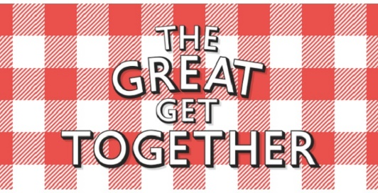 DAMASQ 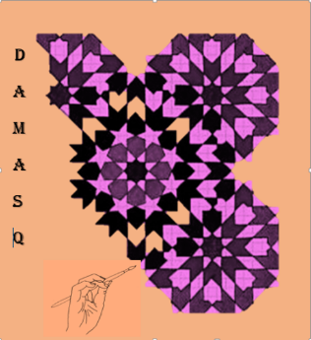

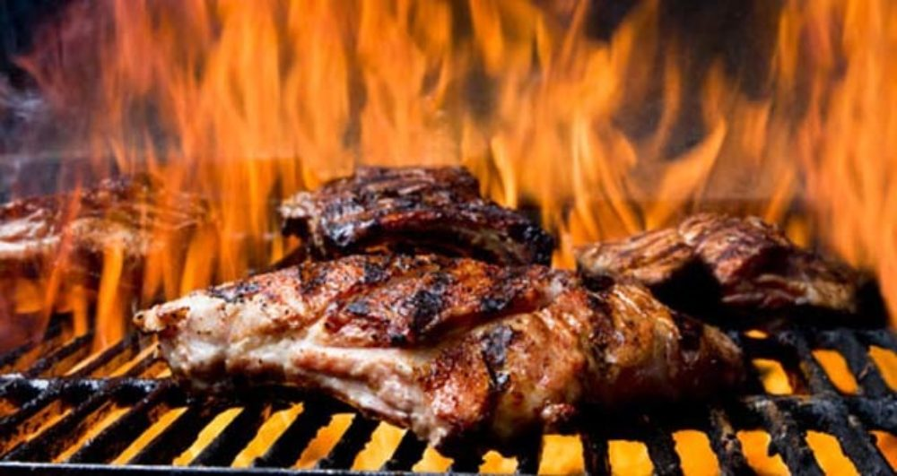

DAMASQ AND THE SYRIAN KITCHEN in COOPERATION WITH LEEDS CITY COUNCIL
Invites you to the Great get together celebration and Leeds open second table tennis tournament for the refugee week 2018, Big Revival Bike event 2018.
FREE BBQ. A great family event
FREE DRINKS, Great children Activities
FREEE SYRIAN FRESH BAKERY Sports competitions
FREE CANDY FLOSS AND POP CORN Table tennis
The only thing you must pay: Is to pay us a visit
Ebor gardens community centre, 79 Haslewood Drive , LS9 7PS
Sunday the 17th of June 2:30 pm till 8:30pm

