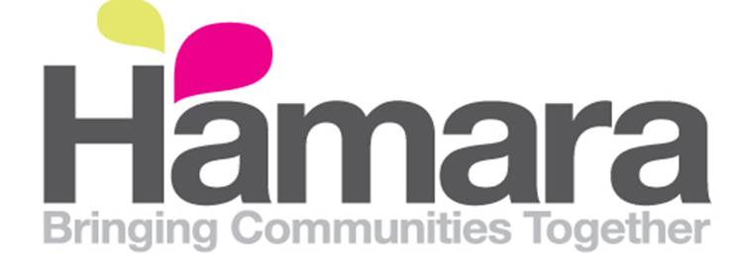
Hamara Healthy Living Centre
Job Description
Job title: Minibus Driver
Service Area: HALO
Responsible for: No line management responsibility
Responsible to: Operations Manager
Type of Contract: Permanent
Hours: 10 hours per week (flexibility in the hours worked will be expected of the post holder, including availability at evenings and weekends).
Salary/Pay rate: £8 per hour
Job Summary/Main purpose of the job:
The Minibus Driver will provide a professional, reliable and safe service to all of its passengers who will travel to and from various locations mainly across Yorkshire. The role will entail driving vulnerable adults and includes pick-ups/drop offs and driving passengers to special excursions
The Minibus Driver will need to hold a current UK driving licence which enables the individual to drive a passenger carrying vehicle with no more than 9 seats but no more than 17 seats in total (D1 of group 2 category). It is essential that the individual has a clean driving licence (no points). The Minibus Driver will need to work collaboratively with other drivers.

Responsibilities/Main Duties:
Minibus Driver:
- Transporting vulnerable adults and any equipment safely in the Minibus in accordance with all traffic laws and all Hamara policies
- The Minibus Driver will be required to carry out daily maintenance and safety checks and to complete the relevant documentation. As detailed in the Drivers Pack
- To ensure that the minibus is adequately fuelled for each journey
- To report any accidents/incidents and near misses to your line manager and complete the appropriate paperwork and provide written reports regarding any accidents/incidents and near misses
- To keep the minibus clean and tidy
- To ensure that all mileage logs and other paperwork relating to the minibus is completed daily and is accurate
- To ensure the serviceability of ancillary equipment i.e. wheelchair ramps used in conjunction with the minibus
- To report to the line manager any safeguarding or customer care concerns promptly and to follow the relevant procedures
- To ensure the First Aid box is checked, the contents are in date and replenished regularly
- Ensure that all receipt for the Fuel card and any other expenses associated with driving duties are retained and submitted to the finance officer on request.

Organisational Requirements
General:
- To support colleagues with any operational needs, as and when required.
- To work outside of ordinary office hours, as required.
- To complete any other reasonable duties, as required.
- To respect and uphold Hamara’s written policies and procedures in place.
- To attend any meetings, as required.
- To commit to personal and professional development. This includes undertaking appropriate training where required, or requested to do so.
- To commit to the ethos and values of Hamara.
- Satisfactory DBS Clearance

Equal Opportunities:
Hamara is an equal opportunities employer. Hamara is committed to promoting anti-discriminatory practices within the society, the organisation and in the promotion of its services to the community. Hamara expects all employees to understand, comply with and to promote its policies in their work and to challenge prejudice and discrimination issues, as appropriate, and undertake any appropriate training.

Safeguarding:
Hamara is committed to ensuring the safeguarding and wellbeing of children and vulnerable adults, and all applicants and staff will be required to demonstrate understanding of and commitment to best safeguarding practice.

Please be aware, you may be expected to do conduct yourself in other ways and undertake different duties which are reasonable, in the opinion of the Company. Your job description is not limited and may be reasonably modified as necessary to meet the needs of the business.

Employee:
Signed
Date:

Employer:
Signed
Date:

Date the Job Description was created: | 29/03/18
Date the Job Description was ratified: | 06/04/18
Signature of Manager who has ratified the Job Description: | Ash Malik

Hamara Healthy Living Centre
Person Specification
Minibus Driver

Criteria | Requirements | Assessment  R = Reference, I = Interview, AF = Application Form and AS = Assessment
Experience
Specialist Knowledge/ Skills | - Knowledge of health and safety issues of driving public vehicles  - Good organisational skills | I, AF & AS  I, AF & AS
Qualifications | - Current UK Driving Licence.  - Clean Driving Licence – no points  - Category D1 licence  - Have a Passenger Vehicle Carrying licence (PCV) | Physical evidence  Physical evidence  Physical evidence  Physical evidence
Interpersonal Skills | - Good verbal and written communication skills  - Ability to work collaboratively with any passengers, other drivers, stakeholders and staff | I, AF & AS  R, I, AF & AS
Other job related requirements | - Must be over 21 years of age  - The willingness to attend training courses as required  - Willingness to work flexible hours where required.  - To complete any other reasonable duties, as required.  - To respect and uphold Hamara’s written policies and procedures in place.  - To attend any meetings, as required.  - To commit to personal and professional development. This includes undertaking appropriate training where required, or requested to do so.  - To commit to the ethos and values of Hamara. | AF  I, AF & AS  I, AF & AS  I, AF & AS  I, AF & AS  I, AF & AS  I, AF & AS  I, AF & AS

