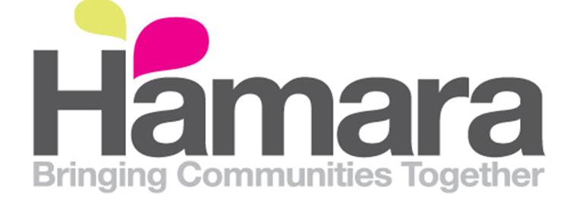

Job Vacancy
Minibus Drivers x 2
Hours: 10 hours per week
Salary: £8 per hour
Contract Type: Permanent
Hamara HLC are currently recruiting for two Minibus Drivers. These drivers will provide a professional, reliable and safe service to all of its passengers who will travel to and from various locations mainly across Yorkshire. The role will entail driving vulnerable adults and includes pick-ups/drop offs and driving passengers to special excursions
To apply for the driver role, you will need to hold a current UK driving licence which enables you to drive a passenger carrying vehicle with no more than 9 seats but no more than 17 seats in total (D1 of group 2 category). It is essential that you have a clean driving licence (no points).
Other tasks within the role include:
- Carrying out daily maintenance and safety checks and completing the relevant documentation. As detailed in the Drivers Pack
- Ensuring that the minibus is adequately fuelled for each journey
- Reporting any accidents/incidents and near misses to your line manager, completing the appropriate paperwork and providing written reports regarding any accidents/incidents or near misses
- Keeping the minibus clean and tidy
- Ensuring that all mileage logs and other paperwork relating to the minibus is completed daily and is accurate
- Ensuring the serviceability of ancillary equipment i.e. wheelchair ramps used in conjunction with the minibus
- Reporting to the line manager any safeguarding or customer care concerns promptly and to follow the relevant procedures
If you are interested in the above posts, then an application pack can be obtained from Reception at the Hamara HLC. Or alternatively please email admin@hamara.co.uk for an electronic pack.
Please return completed application forms to: charlene.tyreman@hamara.co.uk Or by post, marked Private and Confidential, to: Hamara HLC, Tempest Road, Leeds, LS11 6RD
All applications must be received by Monday 4th June & 9am. Applications received after the closing deadline will not be considered.

