The next course in your area Venue and dates:
Leeds St Cyprian with St James
Coldcotes Avenue,
Harehills
LS 9 6ND.

Dates: April 18th 9:15 – 11:30am
April 25th 9:15 – 11:30am
May 2nd 9:15 – 11:30am
May 9th 9:15 – 11:30am
May 18th 9:15 – 11:30am
May 23rd 9:15 – 11:30am
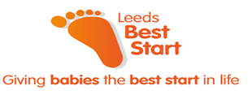
Best Start Peer Support Project (for asylum seekers/Refugees)
Wednesday mornings, St Cyprians Church, Harehills, LS 9 7UQ

Contact:
Meet other parents
لقاء الآباء الآخرين
liqa' alaba' alakhirin

Learn new skills:
: تعلم مهارات جديدة taealam maharat jaded

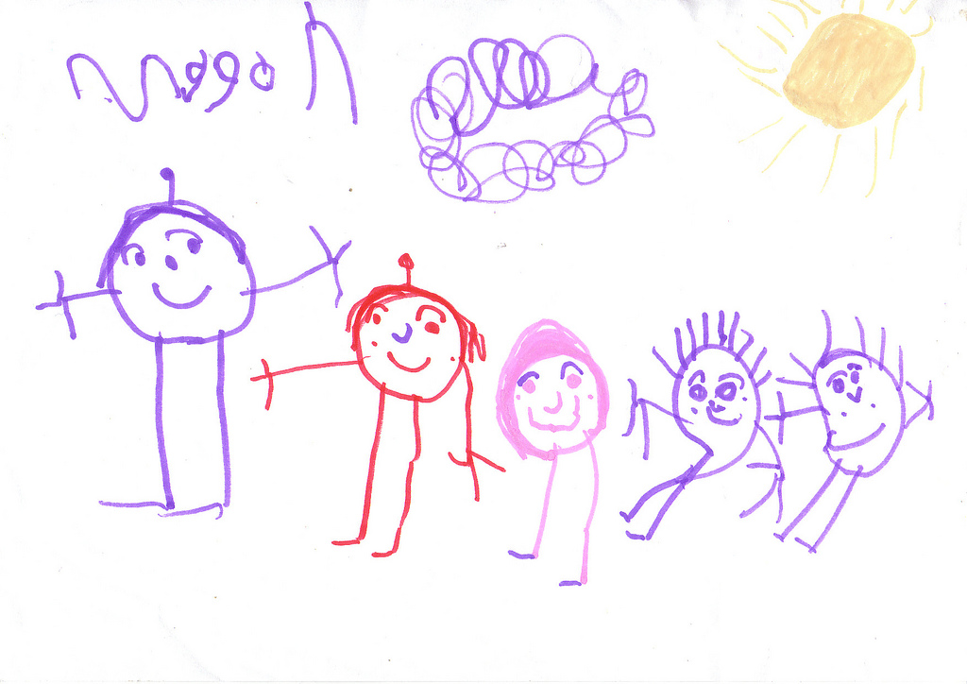

Sign-posted
إشارات
'iisharat

Support
each other
Free crèche
مجانا كريش
majanaan karish

If you are pregnant or a parent or carer of under 2 year olds and live in East or South Leeds, Why not get involved?
Touchstone: Contact Karen Marshall or Emily Wood 0113 2718277

