Regional Report on Migration Issues
Leeds – March 2018

National Migration Statistics & Trends
- Latest migration figures include:

- Net migration for the Year Ending June 2017 was 244 000 (down 29,000 from the previous year, but up 14,000 from the previous quarter)
- This was due to a continuing decrease in immigration (down 50,000, the same as the previous quarter) and an increase in emigration (up 31,000 from the previous year and up 3,000 from the previous quarter).

- Reasons for immigration:

- At 90,000, EU net migration is positive, with more EU nationals arriving than leaving, but the figure continues to fall as fewer EU nationals arrive (especially amongst those arriving for work). EU net migration fell by 75,000 in the past year – it was last at this level in 2012
- At 205,000 non-EU net migration is more than double the EU net migration level, and rising. It increased by 40,000 over the last year. There were particular rises in Asian immigrants and international students, although the latter may only be returning to their previous level after a fall last year.
UK Immigration Policy
The ‘Hostile Environment’
- ‘Right to Rent’ measures, which require landlords to check the immigration status of new tenants, are the subject of an inspection underway by the Independent Chief Inspector. The inspection will look at the initial planning of the scheme, the pilot areas in the West Midlands, enforcement activity and joint working between agencies. At this time the inspection will not look at unintended consequences such as discrimination or homelessness, but is likely to do so in future.

- Checks on all personal bank accounts are now in operation – banks must perform quarterly checks on all personal current account holders. A group of more than 60 MPs, academics and campaign groups have urged the Home Secretary to reconsider the policy, for fear errors could wrongly prevent individuals from accessing their accounts and disproportionately affect BAME and vulnerable people.
NHS Charging Regulations
- A House of Lords debate examined concerns raised by amendments to the NHS Charging Regulations and a health union has pledged to support medical staff who refuse to check patient eligibility prior to treatment. The Department of Health invited evidence for a review of the policy in mid-December 2017 and official guidance on implementing the NHS charges for overseas visitors has been updated: www.gov.uk/government/publications/guidance-on-overseas-visitors-hospital-charging-regulations
- The government has announced that the annual immigration health surcharge, to be paid by certain non-EU migrants will double later this year, from £200 to £400 per year (£300 for students).
Trafficking & Modern-Day Slavery
- The latest National Referral Mechanism (NRM) statistics for Q4 2017 show an 11% increase in referrals from the previous quarter – 1,465 referrals.

- The top nationalities were the UK, Albania and Vietnam (the same as in the previous quarter). The dominant mode of exploitation is now labour exploitation.

- In the region, nearly 60 referrals were made in this period by seven local authorities – Barnsley, Bradford, Calderdale, East Riding, Hull, Leeds and North Yorkshire.

- Practical reforms to support victims of modern slavery have been announced, building on the Anti-Slavery Commissioner’s annual slavery report -www.gov.uk/government/publications/2017-uk-annual-report-on-modern-slavery.

There are some significant changes including:
- a new Home Office decision making unit separate from the immigration system
- an independent expert panel to review all negative decisions
- a new digital system that will improve how victims are referred for support
- new ‘places of safety’, providing immediate support to potential victims to be able to leave exploitative situations and receive assistance and advice for 3 days before deciding whether to enter the NRM
- extension of the ‘move-on’ support period from 14 to 45 days after a decision (in addition to the existing 45 days while a decision is reached),
- drop-in services for confirmed victims who are transitioning out of the NRM for up to 6 months
- national rollout of Independent Child Trafficking Advocates (currently operating in Wales, Hampshire and Greater Manchester)
- work with local authorities to develop best practice in transitioning victims to local community services
- subsistence rates for victims to be aligned with those already in place for asylum seekers. This is effectively a large cut from £65 to £37.75 per week.
EU Nationals
- The government has shared more plans about the administrative procedure for EU nationals resident in the UK applying for settled status. An overview is summarised in the table below:
Agreement on rights for EU citizens and their families: DExEU/Home Office (Nov 2017) ‘Citizens' rights: administrative procedures in the UK’, Policy Paper, 8 November 2017 www.gov.uk/government/publications/citizens-rights-administrative-procedures-in-the-uk/technical-note-citizens-rights-administrative-procedures-in-the-uk
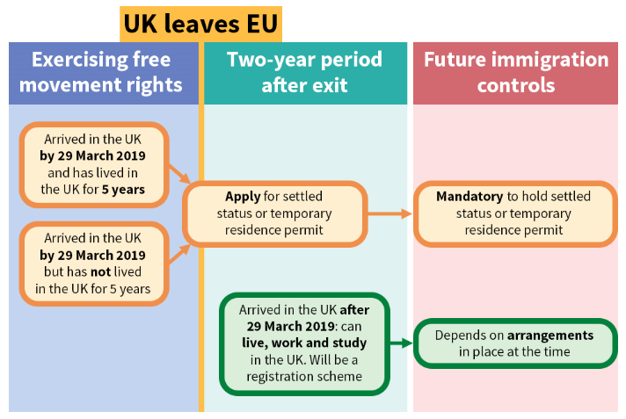
- A new digital system for processing settled status applications is being designed that will minimise the need to produce documentary evidence. The associated fee will not exceed the cost of a British passport. Those already with permanent residence documents will be subject to a simpler process and a lower fee. User groups, including EU nationals in the UK are being consulted about the process.

- In December 2017, a High Court ruling led to the Home Office amending its guidance on deportation of EEA nationals - which since 2016 has stated that rough sleeping is an abuse of freedom of movement rights. The forced removal of EU nationals sleeping rough was deemed to be illegal, as rough sleeping does not constitute an abuse of EU Treaty rights (they may, for example, be working and economically self-sufficient). Official guidance no longer has references to rough sleeping. Factsheets are available for advisers and EU nationals themselves https://nelmacampaigns.wordpress.com/legalchallenge/
Asylum Seekers
- An 80p increase in the cash allowance for asylum seekers took effect from 5th February 2018 – raising the weekly payment from £36.95 to £37.75, following a review of asylum subsistence rates.

- With the procurement process for the new asylum contract underway, the Home Office has responded to the Home Affairs Select Committee January 2017 report on asylum housing, recognising the role of councils, strategic migration partnerships and the voluntary and community sector within asylum and refugee support systems and in managing cohesion concerns in local communities. It also recognised that many councils also support other migrant groups such as UASC and resettled refugees and that this should be taken into account when widening dispersal. https://publications.parliament.uk/pa/cm201719/cmselect/cmhaff/551/55102.htm

- Two new reports have been published, highlighting the experiences of asylum-seeking women. ‘Through Her Eyes’ www.asylumaid.org.uk/womens-project/throughhereyes explores the asylum appeal process and ‘We Are Still Here’ www.refugeewomen.co.uk/research/ focuses on women held in immigration detention.
Unaccompanied Asylum-Seeking Children (UASC)
- Dubs – The UK commitment remains at 480 children, with about 220 having been transferred so far. Initial Dubs transfers slowed down after the dismantling of the Calais ‘Jungle’, but the first child to be transferred from Greece arrived in November 2017 and the ‘relevant date of arrival’ in the EU for eligible children has now been extended from 20th March 2016 to 18th January 2018, potentially making more children eligible for transfer from France, Greece and Italy.

- The National Transfer Scheme continues, with 21 UASC coming to Yorkshire & Humber (Bradford, East Riding, Leeds, NE Lincolnshire & York) during the period July-December 2017.
Resettled Refugees

- In 2017, 4,832 refugees came to the UK under the Vulnerable Persons Relocation Scheme (VPRS – also known as Syrian Resettlement) – 1,202 of these came to Yorkshire & Humber.

- 539 refugees have come to the UK under the Vulnerable Children’s Relocation Scheme (VCRS) from the Middle East & North African regions – 69 of these have come to Yorkshire & Humber.

- The latest resettled arrivals in January 2018 received positive media coverage in our region: www.yorkshireeveningpost.co.uk/news/syrian-refugees-arrive-in-leeds-to-be-resettled-across-yorkshire-1-8963062
Controlling Migration Fund
- The Yorkshire & Humber region has now received £6.5 million of the £34 million available under CMF so far for projects in Barnsley, Bradford, Calderdale, Hull, Kirklees, Leeds, Rotherham, Sheffield & Wakefield.

- In January 2018, £29 million was also made available for UASC CMF projects, including capacity-building for local authorities to meet the needs of UASC. In Yorkshire & Humber three projects have been confirmed, to be led by Leeds City Council, North Yorkshire County Council and York City Council – the latter’s project will work with councils across Yorkshire & Humber.
Asylum Numbers in Leeds & Yorkshire
- The overall number of dispersed asylum seekers in the Yorkshire & Humber region as a whole was 5339 on 01/12/17. This compares to 5222 on 05/12/16 – an increase of 117 or about 2% over the year.

- The number of supported asylum seekers in Leeds, for the latest available Home Office figures in December 2017, was 829, up 90 or about 12% compared to the same time last year. This is 25% below what it would be if dispersal was spread more evenly across the region, and is below the 15% tolerance level agreed informally by Local Authorities in the region.
Migration Yorkshire Training
- Migration Yorkshire offers ‘Introduction to Migration’ training sessions as part of our services to Local Authority partners each year. The 22 sessions for Leeds have been ongoing throughout 2017/18, engaging with a range of services including Public Health, Customer Services and Councillors. The Local Authority have offered one of their sessions to the Leeds voluntary sector, so plans are currently underway to set a date for this voluntary session. All sessions to date have been well-received.
Liz Maddocks/Bill Dennis, Migration Yorkshire
March 2018

