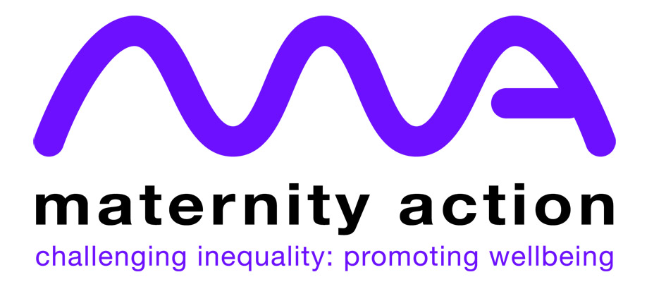
Free training for midwives and
voluntary sector workers and volunteers
This free one day introductory training course aims to equip participants with the knowledge to help destitute migrant women access accommodation and support during their pregnancy or new motherhood. It also provides an overview of NHS charging regulations. The training will cover the following areas.
- An overview of the various groups of migrants living in the UK and the different immigration status they may hold
- A guide to the various support options available to migrant women in the UK
- A guide to the NHS charging regulations including migrant groups and services exempt from charging
- Access to maternity care for migrant women
- Advising women who have received a bill for maternity care
- List of projects offering specialist help to destitute migrant women, including those who are victims of trafficking and gender based violence.
When: Thursday, 15th February 2018 10:00am – 3:00pm
Where: Refugee Council | Puffin Room, 2nd Floor Oak House 94 Park Lane Leeds LS3 1EL
To book a place please email: renatamalzoni@maternityaction.org.uk

