Providing supported
accommodation to women.

Purlin House, Bradford

How we can help
Purlin House offers secure accommodation for single women in Manningham.
We offer a housing management service for women with low-medium support needs.
The housing team are based a short distance away at 43 Blenheim Road and visit site daily.
We have 9 self-contained flats and 4 bedsits with a shared kitchen and bathroom.

The building is covered extensively with CCTV and female only security staff every evening and weekend.

Staff will work with customers to ensure they are tenancy ready for them to gain their own permanent accommodation. The housing team can refer customers to support agencies if required.

Referrals are accepted from local authority, external support agencies, voluntary and self-referrals.

Housing Officers are based at Blenheim Monday to Friday, 9am until 5pm, to help with all tenancy related issues, repairs, benefits etc.
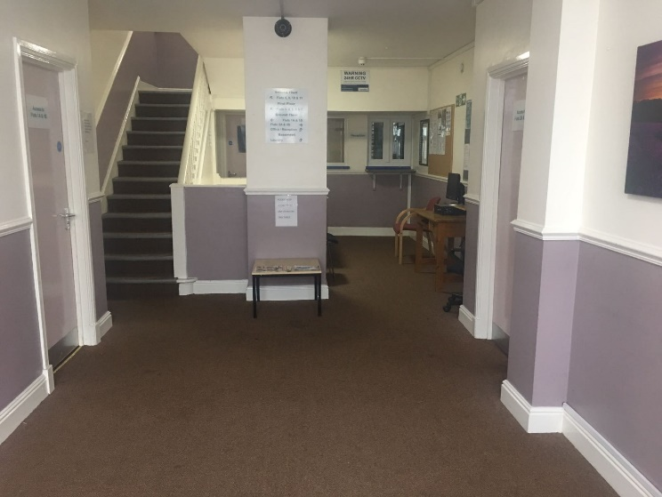
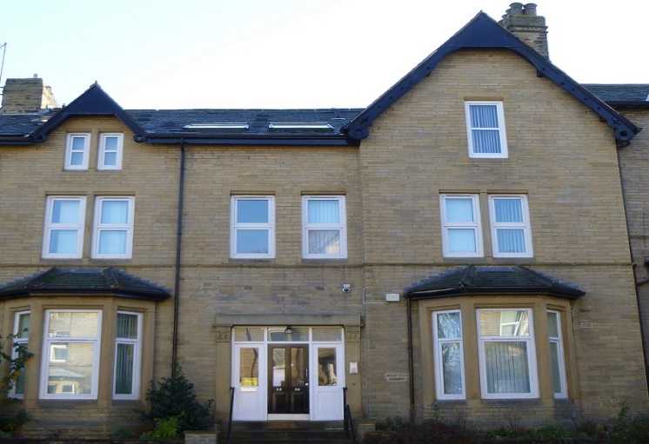
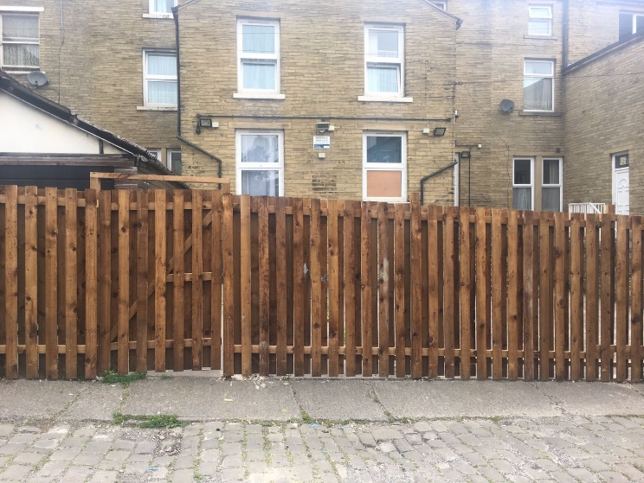
Facilities and services
- Security staff throughout the night.
- On site laundry.
- Newly renovated apartments and houses in an ideal city centre location.
- Fenced garden to the rear of the property.
- Site inspections conducted weekly, staff visits daily.
- Referral available to support agencies.
- Extensive CCTV throughout site for safety and security.
- Donations from other agencies available in reception.
- Sign posting to volunteer groups.

Accommodation is not permanent and resettlement will be pursued when each customer feels confident to do so.
An average stay will be between 6 and 18 months.

Purlin House offers short term, temporary accommodation to people in need of housing with low to medium support needs. Staff will assist in finding your forever home.

For more information
about Purlin House:
If you would like to find out who to contact
for a referral or would like more information, please contact us at:
Address: Bradford Project
43 Blenheim Road
Bradford
BD8 7LH

Tel: 01274 496251
Email: bradfordproject@riverside.org.uk

About Riverside Care & Support
Riverside Care and Support is a registered provider of retirement living and supported housing throughout the UK. We promote
independent living and deliver innovative
and community based services, achieving successful outcomes for our customers.
To find out more about Riverside nationally, contact us using the details below.

