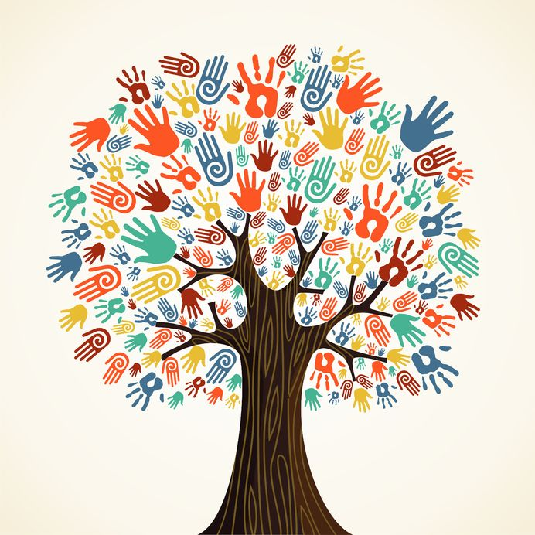
As part of the Jo Cox Loneliness Commission, Leeds Survivor Led Crisis Service invites you to an event to hear from refugees and asylum seekers about their experience of loneliness and what helped.

Keynote speaker Rachel Reeves MP, Co-Chair of the Jo Cox Loneliness Commission

During 2017, the Jo Cox Loneliness will focus on loneliness in different groups within the UK. In October, the Refugee Council are leading on a month of campaigning about loneliness in refugee and asylum seeker communities.

Friday 13th October 11-2, Shine.
Harehills Road, Leeds LS8 5HS
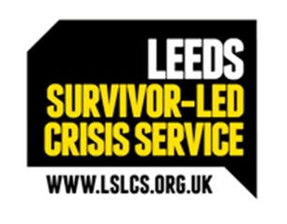

RSPV: Please email
Survivor.led@lslcs.org.uk

